# *"ज्ञान, विज्ञान आणि सुसंस्कार यासाठी शिक्षणप्रसार"*

-शिक्षणमहर्षी डॉ. बापूजी साळुंखे

# Shri Swami Vivekanand Shikshan Sanstha, Kolhapur’s

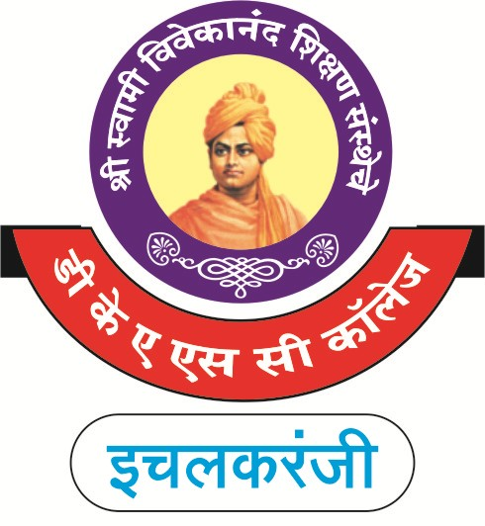**Dattajirao Kadam Arts, Science & Commerce College, Ichalkaranji**

# Annual Quality Assurance Report (AQAR)

***Of***

***Internal Quality Assurance Cell (IQAC)***

***(Academic Year 2014 – 15)***

**Submitted to,**

**NATIONAL ASSESSMENT AND ACCREDITATION COUNCIL**  
Bangalore - 560 072 India

**CONTENTS**

**Page Nos.**

**Part – A**

1. Details of the Institution 01 - 04

2. IQAC Composition and Activities 05 - 08

**Part – B**

3. Criterion – I: Curricular Aspects 09 - 10

4. Criterion – II: Teaching, Learning and Evaluation 11 - 14

5. Criterion – III: Research, Consultancy and Extension 15 - 19

6. Criterion – IV: Infrastructure and Learning Resources 20 - 21

7. Criterion – V: Student Support and Progression 22 - 25

8. Criterion – VI: Governance, Leadership and Management 26 - 31

9. Criterion – VII: Innovations and Best Practices 32 - 34

Annexure – I: Academic Calendar ...... 35

Annexure – II: Best Practices of the Institution 36 - 37

Annexure – III:Administrative and Academic Audit Committee

Report 38 – 43

Annexure – IV: Compliance Report 44 – 47

Annexure – V : Achievements 48 – 50

**Part – A**

**1. Details of the Institution**

Dattajirao Kadam Arts, Science & Commerce College, College, Ichalkaranji.

1.1 Name of the Institution

Near Shahu Putala, Shivajinagar, Kolhapur Road, Ichalkaranji.

1.2 Address Line 1

Tal. Hatkanangale Dist. Kolhapur.

Address Line 2

ICHALKARANJI

City/Town

MAHARASHTRA

State

416115

Pin Code

dkasccollege@gmail.com

Institution e-mail address

0230/2420412

Contact Nos.

Dr. Milind S. Hujare

Name of the Head of the Institution:

0230/2424555

Tel. No. with STD Code:

9890004144

Mobile:

Dr. C. R. Patil

Name of the IQAC Co-ordinator:

Mobile:

9822521827

IQAC e-mail address:

dkasciqac@gmail.com

1.3 NAAC Track ID EC/54/RAR/068

[www.dkasc.ac.in](http://www.dkasc.ac.in/)

1.4 Website address:

<http://dkasc.ac.in/uploads/AQARs/AQAR2014-15.docx>

Web-link of the AQAR:

1.5 Accreditation Details

|  |  |  |  |  |  |
| --- | --- | --- | --- | --- | --- |
| Sl. No. | Cycle | Grade | CGPA | Year of Accreditation | Validity Period |
| 1 | 1st Cycle | B |  | 2004 | 16th Feb.2004 to 15th Feb.09 |
| 2 | 2nd Cycle | B | 2.89 | 2010 | 8th Jan.2011 to 7th Jan.2016 |
| 3 | 3rd Cycle |  |  |  |  |
| 4 | 4th Cycle |  |  |  |  |

20/06/2004

1.6 Date of Establishment of IQAC : DD/MM/YYYY

1.7 AQAR for the year

2014-15.

1.8 Details of the previous year’s AQAR submitted to NAACafterthe latest Assessment and Accreditation by NAAC*)*

1. AQAR 2010-2011 (DD/MM/YYYY)
2. AQAR 2011-2012 (30/09/2012)
3. AQAR 2012-2013 (12/02/2015)
4. AQAR 2013-2014 (07/11/2015)
5. AQAR 2014-2015 (11/12/2015)

1.9 Institutional Status

University State Central Deemed Private



Affiliated College Yes No

Constituent College Yes No



Autonomous college of UGC Yes No

Regulatory Agency approved Institution Yes No

(eg. AICTE, BCI, MCI, PCI, NCI)

Type of Institution Co-education Men Women

Urban Rural Tribal

Financial Status Grant-in-aid UGC 2(f) UGC 12B

Grant-in-aid + Self Financing Totally Self-financing

1.10 Type of Faculty/Programme

Arts Science Commerce Law PEI (Phys Edu)

TEI (Edu) Engineering Health Science Management

Shivaji University, Kolhapur

1.11 Name of the Affiliating University *(for the Colleges)*

1.12 Special status conferred by Central/ State Government-- UGC/CSIR/DST/DBT/ICMR etc

Autonomy by State/Central Govt. / University

University with Potential for Excellence UGC-CPE

DST Star Scheme UGC-CE

UGC-Special Assistance Programme DST-FIST

UGC

UGC-Innovative PG programmes Any other (*Specify*)

UGC-COP Programmes

**2. IQAC Composition and Activities**

2.1 No. of Teachers

08

03

2.2 No. of Administrative/Technical staff

10

2.3 No. of students

2.4 No. of Management representatives

02

02

2.5 No. of Alumni

2. 6 No. of any other stakeholder and

00

community representatives

00

2.7 No. of Employers/ Industrialists

00

2.8 No. of other External Experts

2.9 Total No. of members

04

]’

loiouyr

25

2.10 No. of IQAC meetings held

04

2.11 No. of meetings with various stakeholders: No Faculty

Non-Teaching Staff Students Alumni Others

2.12 Has IQAC received any funding from UGC during the year? Yes No

If yes, mention the amount

2.13Seminars and Conferences (only quality related)

(i) No. of Seminars/Conferences/ Workshops/Symposia organized by the IQAC

Total Nos. International National State Institution Level

(ii) Themes

2.14 Significant Activities and contributions made by IQAC

1. Admissions strategies were determined and new course was proposed.
2. Academic Calender of the college and departmental academic plans were prepared.
3. Academic and administrative audit for academic appraisal of the institution (College) executed through Sanstha Peer Team.
4. Internal evaluation tests for students accelerated.
5. Feedback analysis was proposed for various feed backs and procured from students, faculty.
6. Participation of students in issues related with social and environment , enhanced and completed.
7. Augmentation of laboratory requirements of the year.
8. Execution of statutory and non-statutory committees from the beginning of the year.
9. National conferences in History, Hindi were organized.

2.15 Plan of Action by IQAC/Outcome

**Plan of action chalked out by the IQAC in the beginning of the year towards quality enhancement & achievement and the outcome achieved at the end of the year.**

|  |  |  |
| --- | --- | --- |
| **Sr.No.** | **Plan of Action** | **Achievements (Outcome)** |
| 1. | Admission strategies were prepared and new Course “Community College” announced and to be started in the next year. | Admissions were given as per decision. New course “Community College” was designed and to be executed in the next academic year. A proposal was prepared for further necessary action. |
| 2. | Academic Calender of the college and departmental academic plans were prepared. | Both of these were brought into action from the beginning of the year. |
| 3. | Administrative and academic audit of college for academic appraisal by Sanstha’s Peer Team was proposed in February / March. | * For academic appraisal of college,Administrative and Academic audit through Sanstha Peer Team was executed in Feb.2015. Committee report was submitted to the Secretary of Institution and Principal. While compliance report was submitted to Head of the Institution (Secretary) and the Principal. |
| 4. | Internal evaluation tests were proposed. | Besides,and before semester examination internal evaluation tests by various methods were conducted through appointing COE for Arts, Commerce and Science streams. |
| 5. | Feed back analysis proposed. | Feed back of students for curriculum, Institution appraisal and teacher’s evaluation were taken at the end of the semester and also feedback were taken from stakeholders and analysis of all types were prepared for compliances. |
| 6. | Participation of students in issues related with social and environment consciousness activities were proposed. | The awareness activities by students in social and environment issues were organised successfully. |
| 7. | Augmentation of laboratory needs was proposed. | After the budget provisions, laboratory requirement were fulfilled as per purchase committee recommendations by quotation method. |
| 8. | Statutory and Non-statutory Committees were proposed and duties and functions were assigned.. | Besides the curricular activities, for implementation of extra- curricular and administrative activities,Statutory and Non-statutory committees were prepared and brought in force through assigning duties and functions. |
| 9. | National Conferences sanctioned by UGC in Hindi and History are proposed for .organisation | * Two national conferences were organised successfully in Hindi and History for enhancing scientific temper among students, and faculty. |

**\* Attach the Academic Calendar of the year as Annexure: See Annexure – I (Page No. 35)**

2.16 Whether the AQAR was placed in statutory body **Yes** No

√

University Committee

*

Management Syndicate Any Other Body

* Please Refer Annexure – III (Page No. 38-43)

Provide the details of the action taken

1. In the beginning of new academic year; admission strategies were decided for regular U.G. Courses as well as for new course “Community College” course and regular courses were started as soon as first term begins, and a proposal for community college course, was sent for sanction.
2. Academic calendar of the college was prepared and implemented from the beginning of the year . It is printed and submitted to the principal and displayed in staff file for faculty.
3. For academic performance appraisal, Administrative and Academic audit by Sanstha Peer team executed on 27th February,2015. Guidelines and formats for this visit were prepared and informed to all departments for documentation. The inspection report by committee was submitted to principal and Secretary of the Sanstha. Compliance report was prepared and submitted to the Secretary and displayed in Staff file for faculty.
4. Internal evaluations tests by various methods were implemented for continuous assessment of the students. Results were submitted to COE in college and to IQAC for documentation.
5. Feed back of six types from students, faculty, parents, stakeholders were taken and analysis were prepared for compliances.
6. National conferences in History and Hindi were organized successfully in the college for developing research temper within faculty and students. College remain knowledge partner to Jaysingpur college, Jaysingpur for organization of National conference in recent trends in life sciences.
7. NSS, NCC and other students participated in awareness activities in social, environment concern and campaign, rallies, Camps, programmes were organized successfully.
8. For augmentation of laboratory needs, budget provisions were made and needs were fulfilled.
9. For all administrative activities in the college, statutory and non-statutory committees were prepared. Guidelines for duties were provided and brought into force from the beginning of the year.

**Part – B**

**Criterion – I**

**1. Curricular Aspects**

1.1 Details about Academic Programmes

|  |  |  |  |  |
| --- | --- | --- | --- | --- |
| Level of the Programme | Number of existing Programmes | Number of programmes added during the year | Number of self-financing programmes | Number of value added / Career Oriented programmes |
| PhD | -- | 01 Ph.D.Course in Botany. | -- | -- |
| PG | 02 | -- | -- | -- |
| UG | 03 | -- | 02 | -- |
| PG Diploma |  | 01 |  |  |
| Advanced Diploma |  |  |  | 01 |
| Diploma |  |  |  | - |
| Certificate |  |  |  | 02 |
|  |  |  |  |  |
| **TOTAL** | 05 | 02 | 02 | 03 |

|  |  |  |  |  |
| --- | --- | --- | --- | --- |
|  |  |  |  |  |
|  |  |  |  |  |

1.2 (i) Flexibility of the Curriculum: CBCS/Core/Elective option / **Open options**

(ii) Pattern of programmes:

|  |  |
| --- | --- |
| Pattern | Number of programmes |
| Semester | B.A.,B.Com.,B.Sc.,BBA.,BCA,M.A. |  |  |  |
| Trimester |  |
| Annual | Community College |





1.3 Feedback from stakeholders* Alumni Parents Employers Students

***(On all aspects)***



Mode of feedback : Online Manual Co-operating schools (for PEI)

**FEED BACK ANALYSIS**

a) From alumni -

stakeholders

b) Feed back analysis of Institution by students for curriculum aspects

* Language laboratory be generated.

c) Feed back Analysis - evaluation of teachers.

* Some faculty is not engaged in research.

d) Feed back Analysis by faculty about Institution :

i) Transperency in admission process . ii) Infrastructure yet to be generated

iii) Toilets and boys room may be provided.

iv) Internet facility may be provided in staffroom additionally

d) Feedback analysis by students about institution :admission process transperent.

1.4 Whether there is any revision/update of regulation or syllabi, if yes, mention their salient   
 aspects.

Yes new syllabi are implemented from June 2013.

1.5 Any new Department/Centre introduced during the year. If yes, give details.

P.G. Recognition in Botany for M.PhIl.& Ph.D. continued.

**Criterion – II**

**2. Teaching, Learning and Evaluation**

|  |  |  |  |  |
| --- | --- | --- | --- | --- |
| Total | Asst. Professors | Associate Professors | Professors | Others |
| 44 | 20 | 24 | -- | 18 |

2.1 Total No. of permanent faculty

04

17

2.2 No. of permanent faculty with Ph.D. M.Phil.

|  |  |  |  |  |  |  |  |  |  |
| --- | --- | --- | --- | --- | --- | --- | --- | --- | --- |
| Asst. Professors | | Associate Professors | | Professors | | Others | | Total | |
| R | V | R | V | R | V | R | V | R | V |
| 20 | 11 | 24 | 00 | 00 | 00 | 00 | 00 | 44 | 11 |

2.3 No. of Faculty Positions Recruited (R) and Vacant (V) during the year

00

00

12

2.4 No. of Guest and Visiting faculty and Temporary faculty

2.5 Faculty participation in conferences and symposia:

|  |  |  |  |
| --- | --- | --- | --- |
| No. of Faculty | International level | National level | State level |
| Attended Seminars/ Workshops | 00 | 26 | 29 |
| Presented papers | 02 | 51 | -- |
| Resource Persons | -- | 14 | 05 |

2.6 Innovative processes adopted by the institution in Teaching and Learning:

1. Counseling to students for improvement those failed in previous classes
2. Besides semester examinations internal tests were conducted.
3. Faculty published 56 research papers, 28 text books & two proceedings.
4. Two lead college workshops on curriculum were organized.
5. Two faculty registered for Ph.D. and 4 minor research projects were submitted.
6. 51 papers were presented by faculty in National Conferences/Seminars and two papers in International Conferences.
7. 26 National Conferences, 29 workshops,11 seminars were attended by faculty.

2.7 Total No. of actual teaching days

180

during this academic year

2.8 Examination/ Evaluation Reforms initiated by

--

the Institution (for example: Open Book Examination, Bar Coding,

Double Valuation, Photocopy, Online Multiple Choice Questions)

--

--

--

2.9 No. of faculty members involved in curriculum

restructuring/revision/syllabus development

as member of Board of Study/Faculty/Curriculum Development workshop

70%

2.10 Average percentage of attendance of students

2.11 Course/Programme wise

distribution of pass percentage :

**RESULTS OF B.A./B.COM./B.Sc./B.B.A./B.C.A./M.A. Courses – 2014-2015**

|  |  |  |  |  |  |  |
| --- | --- | --- | --- | --- | --- | --- |
| **Subject** | Title of the Programme | **No. of Students appeared** | **No. of Students passed** | **% of passing** | **No. of Students in distinction** | **No. of Students in first class** |
|  | B.A.I | 683 | 355 | 51.97 | --- | -- |
| B.A.-II | 286 | 168 | 58.74 | -- |  |
|  | B.Com.I | 409 | 179 | 51.10 | 05 | 28 |
| B.Sc.I | 373 | 176 | 46.38 | 35 | 36 |
| Marathi | B.A.I Sem.I | 197 | 183 | 92.89 | 18 | 23 |
|  | B.A.I Sem.II | 199 | 179 | 89.94 | 43 | 53 |
|  | B.A.II Sem.III | 58 | 56 | 96.55 | 6 | 10 |
|  | B.A.II Sem.IV | 58 | 53 | 91.37 | 17 | 18 |
|  | B.A.III Sem.V | 16 | 9 | 56.25 | -- | 4 |
|  | B.A.III Sem.VI | 16 | 9 | 56.25 | -- | 5 |
| Geography | B.A.I | 131 | 131 | 100.00 | 18 | 18 |
| B.A.II | 60 | 59 | 98.33 | 16 | 12 |
| B.A.III | 20 | 20 | 100.00 | 10 | 10 |
| Mathematics | B.Sc.I | 211 | 133 | 63.03 | 25 | 47 |
| B.Sc.II | 118 | 89 | 75.42 | 17 | 30 |
| B.Sc.III | 33 | 30 | 90.90 | 19 | 11 |
| Physics | B.Sc.II | 124 | 76 | 76.00 | 18 | 39 |
| B.Sc.III | 19 | 9 | 56.00 | 2 | 6 |
| Electronics | B.Sc.I | 83 | 67 | 80.72 | 18 | 20 |
| B.Sc.II | 52 | 32 | 61.54 | 17 | 11 |
| B.Sc.III | 15 | 13 | 86.66 | 10 | 03 |
| Statistics | B.Sc.I | 224 | 137 | 61.16 | 20 | 38 |
| B.Sc.II | 33 | 33 | 100.00 | 7 | 11 |
| Botany | B.Sc.I | 143 | 130 | 90.90 | 88 | 59 |
| B.Sc.II | 110 | 103 | 93.63 | 38 | 46 |
| B.Sc.III | 16 | 16 | 100.00 | 14 | 02 |
| Zoology | B.Sc.-I | 161 | 132 | 81.98 | 19 | 31 |
| B.Sc.-II | 106 | 83 | 76.30 | 10 | 09 |
| B.Sc.-III | 44 | 35 | 75.55 | 06 | 24 |
| B.C.A. | B.C.A.I | 53 | 39 | 73.58 | 14 | 18 |
| B.C.A.II | 29 | 14 | 48.03 | -- | -- |
| B.C.A.III | 32 | 29 | 93.75 | -- | 11 |

* 1. How does IQAC Contribute/Monitor/Evaluate the Teaching & Learning processes :

* IQAC suggest faculty to undertake the internal evaluation using various methods including participatory teaching method to enhance grasping capacity about taught units and results are shown to students and papers are returned to students. IQAC also advise faculty to mentor students for writing skills before semester examinations.

2.13 Initiatives undertaken towards faculty development

|  |  |
| --- | --- |
| *Faculty / Staff Development Programmes* | *Number of faculty benefitted* |
| Refresher courses | 02 |
| UGC – Faculty Improvement Programme | -- |
| HRD programmes | -- |
| Orientation programmes | 01 |
| Faculty exchange programme |  |
| Staff training conducted by the university |  |
| Staff training conducted by other institutions | 02 |
| Summer / Winter schools, Workshops, etc. |  |
| Others | 05 |

2.14 Details of Administrative and Technical staff

|  |  |  |  |  |
| --- | --- | --- | --- | --- |
| Category | Number of Permanent  Employees | Number of Vacant  Positions | Number of permanent positions filled during the Year | Number of positions filled temporarily |
| Administrative Staff | 11 | 04 |  |  |
| Technical Staff | 39 | 07 |  |  |

**Criterion – III**

**3. Research, Consultancy and Extension**

3.1 Initiatives of the IQAC in Sensitizing/Promoting Research Climate in the institution

1. IQAC has established Research promotion cell (Committee) to enhance scientific temper and research activities within faculty and advised for students’ participation. As a result faculty published 56 papers ;twelve faculty are research guides and till date 35 students are registered for Ph.D.; 8 for M.Phil.One was awarded degree;4 faculty registered for Ph.D.;Four Minor Research Projects are ongoing. One major project was completed by faculty. Two conferences were organized. Two proceedings were published. Four students registered for Ph.D.
2. Through Science Association', lectures were organized to inculcate research temper within students.

3.2Details regarding major projects

|  |  |  |  |  |
| --- | --- | --- | --- | --- |
|  | Completed | Ongoing | Sanctioned | Submitted |
| Number | -- | -- | -- | -- |
| Outlay in Rs. Lakhs | -- | -- | -- | -- |

3.3 Details regarding minor projects

|  |  |  |  |  |
| --- | --- | --- | --- | --- |
|  | Completed | Ongoing | Sanctioned | Submitted |
| Number | 01 | 03 |  | 04 |
| Outlay in Rs. Lakhs | 1,10,000/- |  |  |  |

3.4 Details on research publications

|  |  |  |  |
| --- | --- | --- | --- |
|  | International | National | Others |
| Peer Review Journals | 02 | 18 |  |
| Non-Peer Review Journals |  |  |  |
| e-Journals |  |  |  |
| Conference proceedings |  | 04 |  |

3.5 Details on Impact factor of publications:

Range Average h-index Nos. in SCOPUS

3.6 Research funds sanctioned and received from various funding agencies, industry and other organisations

|  |  |  |  |  |
| --- | --- | --- | --- | --- |
| Nature of the Project | Duration  Year | Name of the  funding Agency | Total grant  sanctioned | Received |
| Major projects |  |  |  |  |
| Minor Projects | 2012-14 | UGC | 40000 |  |
|  | 2012-14 | UGC | 50000 | 40000 |
|  | 2012-14 | UGC | 75000 |  |
|  | 2012-14 | UGC | 90000 | 75000 |
|  | 2013-15 | UGC | 135000 | 133000 |
|  | 2013-15 | UGC | 115000 | 90000 |
| Interdisciplinary Projects |  |  |  |  |
| Industry sponsored |  |  |  |  |
| Projects sponsored by the University/ College |  |  |  |  |
| Students research projects  *(other than compulsory by the University)* |  |  |  |  |
| Any other(Specify)IQAC grant2012-2017 |  |  |  |  |
| Total |  | U.G.C | 505000 |  |

--

16

3.7 No. of books published i) With ISBN No. Chapters in Edited Books

ii) Without ISBN No.

3.8 No. of University Departments receiving funds from

UGC-SAP CAS DST-FIST

DPE DBT Scheme/funds

3.9 For colleges Autonomy CPE DBT Star Scheme

INSPIRE CE Any Other (specify)

UGC

----------------

3.10 Revenue generated through consultancy

3.11 No. of conferences organized by the Institution

|  |  |  |  |  |  |
| --- | --- | --- | --- | --- | --- |
| Level | International | National | State | University | College |
| Number |  | 01 |  |  |  |
| Sponsoring agencies |  | UGC |  |  |  |

14

3.12 No. of faculty served as experts, chairpersons or resource persons

3.13 No. of collaborations International National Any other

3.14 No. of linkages created during this year

3.15 Total budget for research for current year in lakhs :

18,000/-

From Funding agency From Management of University/College

Total

|  |  |  |
| --- | --- | --- |
| Type of Patent |  | Number |
| National | Applied |  |
| Granted |  |
| International | Applied |  |
| Granted |  |
| Commercialised | Applied |  |
| Granted |  |

3.16 No. of patents received this year

3.17 No. of research awards/ recognitions received by faculty and research fellows

|  |  |  |  |  |  |  |
| --- | --- | --- | --- | --- | --- | --- |
| Total | International | National | State | University | Dist | College |
|  |  |  |  |  |  |  |

Of the institute in the year

3.18 No. of faculty from the Institution

12

who are Ph. D. Guides

and students registered under them: Ph.D. M.Phil.:

08

25

3.19 No. of Ph.D. awarded by faculty from the Institution

00

3.20 No. of Research scholars receiving the Fellowships (Newly enrolled + existing ones)

-

-

-

-

JRF SRF Project Fellows Any other

3.21 No. of students Participated in NSS events:

200

University level State level

01

01

National level Regional level

200

3.22 No. of students participated in NCC events:

02

500

University level State level

National level Other level

01

05

3.23 No. of Awards won in NSS:

--

--

University level State level

--

--

National level International level

3.24 No. of Awards won in NCC:

University level State level

1 Gold

01

--

-

National level Regional level

3.25 No. of Extension activities organized

02

01

University forum College forum

05

07

01

NCC NSS Any other

State level NSS

3.26 Major Activities during the year in the sphere of extension activities and Institutional Social   
 Responsibility

NSS and NCC students implemented following extension activities in social and environment concern.

* 1. Road safety campaign.
  2. Campus and classroom cleaning.
  3. AIDS awareness Rally.
  4. Blood donation camp.-134 bags donated to blood bank .
  5. Wheel chair donation to Physically disabled student.
  6. Plantation.
  7. Siber-crime lecture was organised.
  8. Nirmalya collection during Lord Ganesh festival.
  9. Awarness about donation of status of Lord Ganesh during festival.
  10. Donation of 10 boys cloths and 2 sacks of sugar to Anandvan Ashram to Dr Perkash Amate.
  11. Programm on ‘Superstitions Eradication’ was organised.
  12. One NSS Volunteer participated in National integration camp.
  13. 35 NCC Cadets donated blood.
  14. NCC cadets attended 12 camps.
  15. Participation in Vivekanand Jayanti Saptah-academic activities.

**Criterion – IV**

**4. Infrastructure and Learning Resources**

4.1 Details of increase in infrastructure facilities:

|  |  |  |  |  |
| --- | --- | --- | --- | --- |
| Facilities | Existing | Newly created | Source of Fund | Total |
| Campus area | 3.74 acres. | -- |  |  |
| Class rooms | 35 | - | - | - |
| Laboratories | 12 | B.C.A. Lab. | Sanstha | 26,00,000 |
| Seminar Halls | 01 | - | UGC | - |
| No. of important equipments purchased (≥ 1-0 lakh) during the current year. |  |  | - | - |
| Value of the equipment purchased during the year (Rs. in Lakhs) |  |  | UGC | 3100 |
|  |  |  |  |  |

4.2 Computerization of administration and library

Computer facility with internet provided to Laboratories in office, faculty; and students in library, I.T.

4.3 Library services:

|  |  |  |  |  |  |  |
| --- | --- | --- | --- | --- | --- | --- |
|  | Existing | | Newly added | | Total | |
| No. | Value | No. | Value | No. | Value |
| Text Books | 25973/- | 1252440/- | 761 | 62396/- | 26734 | 1314836/- |
| Reference Books | 28886/- | 1745623/- | 128 | 58138/- | 29014 | 1803761/- |
| e-Books |  |  |  |  |  |  |
| Journals | 35 | 19487/- | - | - | 35 | 19487/- |
| e-Journals | - |  |  |  |  |  |
| Digital Database |  |  |  |  |  |  |
| CD & Video | 35 | 5,200/- | - | - | 35 | 5,200/- |
| Others (specify) |  | Free online accession |  |  |  |  |
| Newspapers | 13 | 18971/- | - | - | 13 | 18971/- |

4.4 Technology up gradation (overall)

|  |  |  |  |  |  |  |  |  |
| --- | --- | --- | --- | --- | --- | --- | --- | --- |
|  | Total Computers | Laboratorie | Internet | Browsing Centres | Computer Centres | Office | Depart-ments | Others |
| Existing | 31 | 15 | 03 | 11 | 50 | 10 | -- | -- |
| Added | 51 | -- | - | - | - | 03 from MRP | - | -- |
| Total | 82 | 15 | 03 | 11 | 50 | 13 | -- | -- |

4.5 Computer, Internet access, training to teachers and students and any other programme for technology upgradation (Networking, e-Governance etc.)

Internet facilities were made available in the Staffroom / Library/Office and science departments, NCC Office ,NAAC Office

4.6 Amount spent on maintenance in lakhs :

51,053/-

i) ICT

ii) Campus Infrastructure and facilities

iii) Equipments

iv) Others - Library

51,053/-

**Total :**

**Criterion – V**

**5. Student Support and Progression**

5.1 Contribution of IQAC in enhancing awareness about Student Support Services

1. IQAC promote the students to participate in curricular, co-curricular, extra-curricular activities in the extension services in social as well as environment Conciousness issues.
2. Personality development programme was organized.
3. Career guidance programme was organized by M.B.A. faculty.
4. Investment awareness lecture and financial education workshop was held in college in association with SEBI.
5. Excursion tours, industrial visits were organized
6. Workshops on revised syllabus were organized under lead college activity programme of University.
7. Guest lectures on various subjects were organized for students.
8. Though Science association, various lectures were organized to enhance scientific temper within students.

5.2 Efforts made by the institution for tracking the progression

As soon as the admissions process completed. Students were availed 'I' cards, borrow cards to issue books from central library and departmental libraries (Science). Internal evaluation tests were undertaken before semester examination begins so as to enhance the writing skills of students. Answers books were checked, mark sheets were prepared conserved for documentation.

|  |  |  |  |  |  |
| --- | --- | --- | --- | --- | --- |
| UG | PG | |  | Ph. D. | Grand Total |
|  | Hindi | Mar | Total |  |  |
| 2870 | 72 | 55 | 127 | 12 | 3009 |

5.3 (a) Total Number of students

(b) No. of students outside the state

-

-

(c) No. of international students

|  |  |  |
| --- | --- | --- |
| Men | No | % |
| 1588 | 55.33 |

|  |  |  |
| --- | --- | --- |
| Women | No | % |
| 1282 | 46.66 |

|  |  |  |  |  |  |  |  |  |  |  |  |  |  |
| --- | --- | --- | --- | --- | --- | --- | --- | --- | --- | --- | --- | --- | --- |
| Last Year 2012-13 | | | | | | | This Year 2013-14 | | | | | | |
| Open | SC | ST | OBC | SBC | Phy. Chall-enged | Total | Open | SC | ST | OBC | SBC | Phy. Chall-enged | Total |
| 685 | 220 | 02 | 150 | 207 | 01 | 1423 | 1143 | 360 | 02 | 189 | 270 | 01 | 2134 |

Demand ratio 360:650 Dropout % 0.89

5.4 Details of student support mechanism for coaching for competitive examinations (If any)

College established MPSC coaching centre and conduct and remedial coaching

60

No. of students beneficiaries MPSC :

5.5 No. of students qualified in these examinations

-

-

-

-

NET SET/SLET GATE CAT

IAS/IPS etc State PSC UPSC Others

-

-

-

-

5.6 Details of student counselling and career guidance

The student counselling was undertaken for students about paper writing skills before semester examination. Besides this, to enhance the writing speed continuous evaluation by various methods was practised which resulted in good performance in semester results.

For last year students, career guidance cell organized 'Campus'. Lecture on Entrepreneurship was organized. Police and students communication lecture was organized. Voter's campaign was organized. Investor awareness programme was organized related to banking. Personality development and training in Tally was organized for commerce students.

428

No. of students benefited

5.7 Details of campus placement

|  |  |  |  |
| --- | --- | --- | --- |
| ***On campus*** | | | ***Off Campus*** |
| Number of Organizations Visited | Number of Students Participated | Number of Students Placed | Number of Students Placed |
| INFOSYS | 18 | 06 | Data Not Available. |

5.8 Details of gender sensitization programmes

* Sexual harassment prevention committee established to resolve the problems if therein.
* Anti-ragging committee was established composing psychologist and legal advisor.
* Student redresal and Grievances, and discipline Committees were formed.
* Worshop on 'gynological problems and Cancer' was organised for women.
* Women's empowerment and gender sensitisation programmes were held.

5.9 Students Activities

5.9.1 No. of students participated in Sports, Games and other events

01

02

01

01

State/ University level National level International level

No. of students participated in cultural events

109

-

State/ University level National level International level

5.9.2 No. of medals /awards won by students in Sports, Games and other events

01

02

Sports : State/ University level National level International level

-

Cultural: State/ University level National level International level

5.10 Scholarships and Financial Support

|  |  |  |
| --- | --- | --- |
|  | Number of  students | Amount |
| Financial support from institution (SAF) | 43 | 21,500.00 |
| Financial support from government | 1103 | 6,05,866.00 |
| Financial support from other sources |  |  |
| Number of students who received International/ National recognitions |  |  |

5.11 Student organised / initiatives

1) Teacher's day - 5th Sept. - Mock teaching

2) Guru Pournima - Felicitation of teachers by students

3) Raksha Bandhan - inculate friendship and good relationship.

4) Traditional day - way of showing culture of India

5) Celebration of birth day and death anniversaries of National heroes to remind and follow the contributions made by them and awareness among students.

6) Celebration of language, literacy, National Integration days.

7) Exhibition on gift articles from plant resources

8) Poster exhibition on Indian Scientists, botanists to aware students about contributions of scientists in the society and develop scientific temper and new discoveries.

9) Celebration of Internationa lozone day 16th Sept.

10) Poster and wall paper presentations on syllabi units and on issues in social concern.

11) Program on eradication of superstitions and awareness.

12) Rally organized to protest Doctor Dabholkar Assassination.

13) Organization of Quiz competitions.

5.12 No. of social initiatives undertaken by the students

06

1. Nirmalya collection by students during Lord Ganesh festival at Panchganga river.
2. Article published (in 'Vivek' annual magazine of college for students) regarding 'Superstitions' for awareness of superstitions eradication
3. Article published in 'Vivek' regarding 'Terrorism" and consequences to aware the society.
4. Article published in 'Vivek' regarding awareness about dowery system, female baby foeticides, sexual harassment
5. Article published in 'Vivek' regarding importance of Education in life to aware society about literacy.
6. Article published in Vivek' on 'Save baby girl' to create awareness.

5.13 Major grievances of students (if any) redressed: One case was noticed and resolved.

**Criterion – VI**

**6. Governance, Leadership and Management**

6.1 State the Vision and Mission of the institution

**Mission :** Education for knowledge, Science and Refinement

**- Shikshan Maharshi Dr. Bapuji Salunkhe**

**Vision**  : To become a leading Institute by providing quality education for the all round development of the students with holistic concern for environment, ethics and to serve the society.

Shri Swami Vivekanand Shikshan Sanstha, Kolhapur is one of the

nowned educational institutions in the educational map of India and it is a second largest multi-dimensional educational institution in Maharashtra State established in 1954.

To dedicate itself sanstha adopted this motto representing its goals as -

* To bring about a social change in common man’s life through spread of education.
* To inculcate the basic beliefs in life, truth, honesty, character, love, social service, sacrifice and to do away with exploitation, being the aim of our Sanstha.
* To provide primary, secondary and higher education in Arts, Science, Commerce, Agriculture, Social Science, Technical, Law, Education, Nursing, Engineering, biotechnology and professional education etc.
* thereby effecting cultural growth of the society at large.
* To produce model and devoted social workers whose aptitude is desire to bring about social development.
* The management lays emphasis on the purity of thought, action and word.
* There shall be no discrimination on grounds of caste, creed, religion or colour in the society and in all its branches.
* The management shall keep itself aloof from politics.
* Following the model of the ancient ***Gurukul*** system teacher-cum-worker shall act as a model educator and thereby give rise to new educational system, which will lay stress on sacrifice, honesty, truth, equality and brotherhood.

6.2 Does the Institution has a management Information System

Administrative office of college has been fully automized for communication with faculty and students. About admission process the transperancy is maintained concerning courses, accounts, examination systems and issues related to college, faculty development.

6.3 Quality improvement strategies adopted by the institution for each of the following:

6.3.1 Curriculum Development

Curriculum development, management of college has no right for framing the syllabi. Academic council through BOS commences the curricula. For its implementation, workshops were organized based on new syllabi under lead college activity programme of University.

6.3.2 Teaching and Learning

1. After the semester results, faculty identify the students who had slow performance; they were advised for guidance for improvement in respective subjects. While students with 1st class were also advised for improvement in the next classes.
2. Feed backs about curriculum and teacher's evaluation were taken from students. Suggestions procured from them were used for compliances which helped in both the processes.
3. To enhance the grasping of curriculum units, seminar group discussions and unit tests were implemented and evaluated which helped in improvement in performance.
4. faculty which resulted more improvement in understanding (learning) process.

6.3.3 Examination and Evaluation

1. After the semester examination first year class papers were evaluated at CAP centre in college, mark-sheet were sent online to University while remaining classes evaluation were completed at CAP centre of University and all permanent faculty successfully conducted evaluation work. However, internal evaluation by various methods was executed in college and mark-sheets were displayed on notice boards and maintained in the departments for student performance appraisal.

6.3.4 Research and Development

1. Research promotion cell encourages faculty for inculcating research attitude, participation and paper reading in conferences, and publication of research papers, organizing conferences. That resulted in publication of 56 research papers, organization of two National Conferences in Hindi and History and publication of two proceedings of Conferences in Manchester' with ISBN Numbers, publication of 18 text books, having 12 research projects , chairing 8 sessions in Conferences, presentation of 51 research papers in Conferences, 14 faculty as resource in Conferences, participation in 55 (national & International) Conferences by faculty.

6.3.5 Library, ICT and physical infrastructure / instrumentation

1. Automation (digitization) of library is in process.
2. Computer facilities with internet are provided to library
3. Partial renovation of seminar Hall proposed.
4. Laboratories are provided budget to fulfil routine requirements and for maintenance of equipments
5. New toilet block proposal was sent to Head of the Institution for granting sanction.
   * 1. Human Resource Management

Through statutory and non-statutory committees, faculty is partially involved in administrative help to office and in curricular, co-curricular and extra-curricular activities. Non-teaching staff also render their help in implementing such activities. All teaching and non-teaching staff involved in executing visit of Academic and Administrative Audit of college (Institution) for academic performance appraisal.

6.3.7 Faculty and Staff recruitment

Head of the Institution (Sanstha) look after the vacancies in the colleges and fulfil them as per Government rules and regulations. However, faculty on clock hour basis were appointed at sanstha level through walk in interviews after advertisement in newspapers.

6.3.8 Industry Interaction / Collaboration

* Department of Chemistry established industrial collaboration for project activities. Placement cell organized campus in collaboration with companies like 'Infosys'.
* Department of Commerce organized personality development program and Career Guidance Program was conducted by Ghodavat International Institute and visit was organized by M.B.A. Faculty.

6.3.9 Admission of Students

After board results and University results, all admissions are given purely on merit basis as per University and Government rules, regulations and policies for reservations.

6.4 Welfare Schemes for :

|  |  |
| --- | --- |
| Teaching | TA provided for University, college and CAP duties. |
| Non teaching | TA provided for Institution's, University duties. Substitute holidays on extra duty on holidays. |
| Students | TA and food allowances are provided for quiz, cultural and sports participation. Freeships, scholarships provided under reservations. Group insurance facility made available. Economically weaker students provided financial assistance through student Aid funds. |

**Teaching:** Faculty are provided duty leaves for Conferences, and TA, DA / Registration fees are disbursed to them, while for University & College dutieson duty leaves are given. Personal Loan facility provided from Pat Sanstha.

**Non-Teaching:** Non-teaching on extra duties are given substitute holidays. They were also provided duty leaves on occasion of college/University duties. Uniforms are provided for non-teaching staff. Personal Loan facility provided from Pat Sanstha.

**Students:** Students are paid travelling charges those participated in cultural, sports, exhibitions or any type of curricular, co-curricular or extra-curricular events.

6.5 Total corpus fund generated

---

6.6 Whether annual financial audit has been done Yes No

$$√$$

6.7 Whether Academic and Administrative Audit (AAA) has been done?

|  |  |  |  |  |
| --- | --- | --- | --- | --- |
| Audit Type | External | | Internal | |
| Yes/No | Agency | Yes/No | Authority |
| Academic | Yes | Sanstha | Yes | Sanstha / University |
| Administrative | Yes | Sanstha | Yes | Sanstha / Audit Committee |

6.8 Does the University/ Autonomous College declares results within 30 days?

√

For UG Programmes Yes No

√

For PG Programmes Yes No

6.9 What efforts are made by the University/ Autonomous College for Examination Reforms?

All examination reforms executed by academic bodies of university.

6.10 What efforts are made by the University to promote autonomy in the affiliated/constituent colleges?

------------

6.11 Activities and support from the Alumni Association

Alumini are actively looking into the matters of Institution for performance appraisals. They support the Institution for organizing National Conferences.

6.12 Activities and support from the Parent – Teacher Association

Parents feed backs are taken about Institution and faculty. Institute comply the suggestions received from them.

6.13 Development programmes for support staff

Under the development programme, Non-teaching staff from office was promoted for training for new software skills adopted for scholarships.

6.14 Initiatives taken by the institution to make the campus eco-friendly

* Plantation, cultivation of ornamental plants.
* Cleanliness drive
* Composting of leaf litter
* Recycling of waste papers, news papers, reprography waste paper.
* Power-off whenever classes are vacant.
* Use of rain water for laboratory experiments..

**Criterion – VII**

**7. Innovations and Best Practices**

7.1 Innovations introduced during this academic year which have created a positive impact on the functioning of the institution. Give details.

1. The statutory and non-statutory committees helped the faculty to perform the duties which helped in improvement of activities held during the year.
2. Academic plans of the departments helped the department faculty to improve recreational values, extempore expressing and to develop spirit of healthy competition frankness and overall functioning of the learning process through varietal activities.
3. Field excursions, industrial visits helped the students to inculcate culture, scientific temper, field knowledge.
4. Sanstha's Administrative and Academic audit helped Institutions to improve in academic performance appraisal.
5. Continuous internal evaluation of students through following various methods helped students to improve writing skills and confidence.

7.2 Provide the Action Taken Report (ATR) based on the plan of action decided upon at the

beginning of the year

1. Academic calendar was implemented from the beginning of the academic year. The calendar was printed and provided to each department.
2. Departmental academic plans were prepared and executed.
3. Quotations were sought for the argumentation of infrastructure, improvement in the science laboratories with equipments.
4. Automation of administrative office was completed.
5. Administrative and academic audit was organized for academic and administrative performance, appraisal through Sanstha Peer team.
6. The committee reports were submitted to the Principal and Head of the Institution (Sanstha). Compliance reports were also submitted.
7. Botany laboratory was recognized for M.Phil. and Ph.D. from University.
8. Teachers profile and Departmental profiles were prepared before the visit of Sanstha Peer Team.
9. Internal evaluation by different methods was implemented to enhance the academic performance of the students that results in increase in performance of the students.

7.3 Give two Best Practices of the institution - Administrative and Academic Audit for Academic Performance Appraisal of the Institute (college)

**\* Please Refer Annexure – II (Page No. 36-37)**

7.4 Contribution to environmental awareness / protection

1. Energy Conservation : Notices and implementation regarding power off in the laboratories and classes whenever these are vacant .
2. Wind energy and solar energy conservation proposed for next year.
3. Water Conservation : awareness regarding economical use of water resources in college as well as outside the campus.
4. Plantation : Plantation of few tree seedlings in the campus and cultivation of ornamental plants, conservation of plants in shade Net, plantation preparation in village.
5. Cleaning of premises of college and classrooms.
6. Celebration of International Ozone day 16th September.
7. Organic composting - Notices about not to fire leaf litter in campus and using it for making organic fertilizer by layering method.
8. Awareness among people about donation of statues of Lord Ganesh during 'Visarjan day' in the festival.
9. Collection of Nirmalya during Lord Ganesh festival and avoid people from river water pollution.
10. Under the'Clean India' Campaign announced by Honorable Prime Minister, on the occasion of 'Gandhi Jayanti' Cleanliness drive campaign was organized at Central Bus stand and municipality premises in the city.
11. Installation of fire extinguisher in the office and laboratories and installation of safety measures concerned with electricity.
12. Awareness about use of natural colours made from plant resources instead of using chemical dyes during festival of colour.
13. Awareness regarding avoiding of fire crackers during 'Diwali' festival.
14. Decision for no installation of AC system.
15. Use of papers economically and re-use of reprography waste papers for daily work.
16. Use of rare plants and animal photographs for teaching instead of using live specimens, so as to conserve natural resources.
17. During excursion, plant specimens were collected economically instead of excess collection.
18. Implementation of projects on environmental problems.

7.5 Whether environmental audit was conducted? Yes No

-

7.6 Any other relevant information the institution wishes to add. (for example SWOC Analysis)

**For SWOC Analysis Refer Annexure – IV – Compliance Report (Page N0. 44-47)**

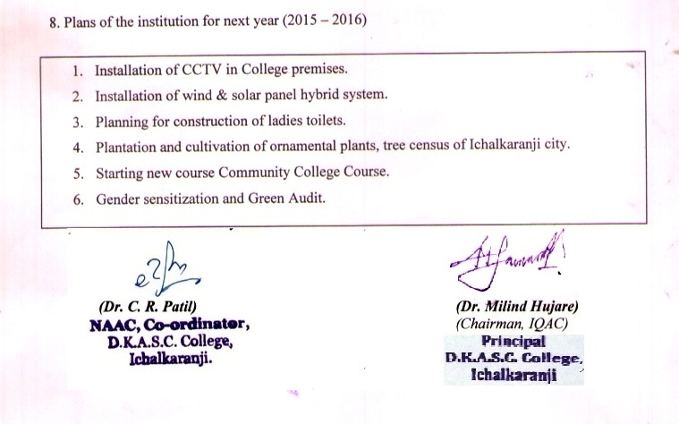

**ANNEXURE – I**

**ACADEMIC CALENDER**

**June 2014 – April 2015.**

* Preparation of College prospectus :- June, 2014.

* Admissions to Regular courses :- June / July 2014.

* Time Table Commencement :- July 2014.

* Formation of Statutory and Non- :- July 2014

Statutory Committees

* First Term Staff Meeting :- July 2014

* Student council and College :- Sept. 2014

Secretary selection.

* Diwali Vacation :- 20th Oct.2014 to 9th Nov.2014

* Internal Evaluation of Students :- Sept. 2014 & Oct. 2014

* Semester Examination :- Oct. 2014 ,Nov. 2013

* Sports events & Cultural :- Nov.2014 & Dec.2014.

Programmes.

* Syllabus completion Report & :- Nov.2014

Feedback.

* Commencement of 2nd Term :- 10.11.2014.

* Second Term Staff Meeting :- Nov.,2014.

* Student Aid Fund Distribution :- Jan. 2015.

* Internal Evaluation Test :- Jan. 2015.

* Campus Organisation :- Jan. 2015

* Sports Events :- Dec. 2014-Jan.2015.

* Physical Education Tests :- Feb.2015

* Academic & Administrative Audit :- Feb. 2015.

by Sanstha Peer Team.

### * Annual Prize Distribution :- Feb.2015

* Internal Evaluation Test :- Feb. 2015.

* Semester Examinations :- Mar., April,May, 2015

* Annual Practical Examination :- Mar., April 2015

* Evaluative Reports of Depts. :- April,2015

* Syllabus completion and feed back reports. :- April,2015

* Performance Based Appraisals :- April,2015

* Summer Vacation :- May- June,2015.

**ANNEXURE – II**

**Administrative and Academic Audit for academic performance Appraisal**

**1) Title of the Practice** **:** Administrative and Academic Audit for academic   
 performance Appraisal

**2) Goal :** To improve academic performance of faculty, students and administration.

**3) Context:**

Any Institution undergoing the NAAC process, have to get audited for academic performance appraisal from external agency or peer team so as to find out strength, weaknesses, opportunities and challenges. In this concern our institution (college) executed the visit of Academic and Administrative Audit for performance appraisal of the Institution for the current academic year. Thereby it may be possible to comply challenging issues for academic improvement of the Institution.

**4) Practice:**

The head of the Institution (Sanstha) proposed to execute Academic and administrative audit of the Institution (College) at the end of the academic year. At first, Secretary notifies the Institution about above said visit and provides formats for academic and administrative audit. The committee composed of three members, of which Principal of any one affiliated college of Sanstha remain Chairman, and a members belong to Senior College and one member belongs to administration office. Before the visit, date was confirmed by the Principal and non-teaching staff.

IQAC of the college notify the entire faculty and held meeting to execute the process of visit. Formats were prepared by IQAC for preparations and provided to the faculty. Guidelines were given to faculty for making teacher profiles, department profiles. The deadline was determined for documentation and one more meeting was held for checking and verification of all the data concerned. Before the committee visit, programme schedule was prepared and displayed for information. On the day of visit, Committee (Peer team) had interaction with the Principal administrative staff. Science department were visited within stipulated time for interaction with the faculty, while faculty of Arts and Commerce had personal interaction in the IQAC office. All the documentation in the profiles were verified by the Committee. At the end, exit meeting was held and the Chairman of the Committee handover the final academic audit visit report to the Principal and meeting was concluded.

For information, a copy of report of committee was displayed in staff file as well as one a copy was sent to the Secretary of the Sanstha at Head Office for information.

After the report resubmission, meeting was called in the Head Office todisucss the issues. During this meeting IQAC prepare compliance report with SWOC analysis. The compliance report was also sent to the Head Office.

**5. Evidence of success:**

Sanstha's Administrative and Academic audit committee visited the Institution and reported weaknesses, opportunities, challenges of the Institution. Among the weaknesses less no. of P.G. departments, lack of playground, more participation of faculty in research, vacant posts of non-teaching staff, laboratories to be provided with more equipments. The Institution tried to comply them. At present two P.G. courses are run and due to lack of infrastructure and increased strength, more space may not be provided for such courses. Only P.G. by research for M.Phil. and Ph.D. in Botany continued while in Commerce, English, Hindi, Physics, Zoology faculty guiding students for M.Phil. and Ph.D. Among the 45 permanent faculty 12 are research guides, 17 acquried Ph.D. and 8 faculty acquired M.Phil. degree. Till date 35 students were registered for Ph. D. and 8 for M.Phil. 56 research papers were published by faculty. There were vacant posts in non-teaching which will be filled by Sanstha as per Government rules and regulations. Within the regular budget laboratory needs are fulfilled for increasing the equipments. Though college have no owned playground, sports activities are implemented at Muncipalty play groun, high school playgrounds and resulted very good achievements in Athletics, Kho-kho, volley-ball, Yoga, Tikwond, Weight lifting, Physic, Indo Body building at Zonal, Interzonal, Inter-University, University and State levels. Among the challenges committee reported about all on courses, organization of Conferences, promoting research culture, decreasing strength of BBA course, increase in co-curricular activities.

Two proposals were submitted under add-on courses to UGC but these were not sanctioned by UGC. Proposal of community college was sanctioned by UGC. Among the four conference proposals submitted last year, all were sanctioned and National

Conferences in Hindi and History were organized while Conference in English will be held in the next year. Research promotion cell was established, encouraged faculty for UGC proposals, 4 MRP proposals were submitted to UGC, three MRP projects are ongoing.

The strength of BBA course, all over in the affiliated colleges was decreased. Institution encourages students for co-curricular activities, various types of them were organized which resulted high degree of passing of students in last year. These activities improve the academic of students. Besides these, though NSS, NCC students had substantial contribution in activities of social and environment concern.

**6. Problems encountered and Resources required:**

Institution makes all the possible provisions to faculty for pre-preparation before committee visit. Due to lack of some non-teaching staff, it becomes difficult to manage all the preparations, processes within stipulated time by completing the routine time-table of classes, teaching and practicals, but faculty spare more time for completion of the duties during visit.

**ANNEXURE - III**

**Administrative and Academic Audit Committee Report**

**of Mahavidyalayin Vidya Samiti ( 2014-2015)**

“&ana, iva&ana AaiNa sausaMskar yaaMsaazI iSaxaNa p`saar”

- iSaxaNamahYaI- Da^.baapUjaI saaLuMKo

**Shri Swami Vivekanand Shikshan Sanstha, Kolhapur,**

**Mahavidyalayin Vidya Samiti**

**Abstract of the College and Assessment Report.**

1. Name of the College :- Dattajirao Kadam Arts,Science & Commerce

College, Ichalkaranji.

1. Name of the Principal :- Dr.Milind Shivajirao Hujare
2. Date of Assessment :- 27.02.2015
3. Course run by College :- B.A., B.COM., B.SC., B.B.A.,B.C.A.M.A.,
4. Staff of Sr. College :- 45

|  |  |  |  |
| --- | --- | --- | --- |
| **Ph. D.** | **M. Phil** | **PG** | **Total** |
| 16 | 8 | 21 | 45 |

6. Non Grantable Courses :- M.A.,B.B.A.,B.C.A.

7. Non Grant Staff Sr. :- 18

8. Student Strength Sr. :- 2575

|  |  |  |
| --- | --- | --- |
| Grantable | Non-Grantable | Total |
| 2575 | 303 | 2878 |

9. Sr. College Strength ( Grantable +Non-Grantable )

Boys :- 1726 Girls :- 1152

|  |  |  |  |  |  |  |  |
| --- | --- | --- | --- | --- | --- | --- | --- |
| Open | SC | ST | NT | OBC | SBC | Minority | Total |
| 1986 | 318 | 2 | 162 | 254 | 156 | 0 | 2878 |

10. Sr. College Results :- ( Last Year )

|  |  |  |  |  |  |
| --- | --- | --- | --- | --- | --- |
| B.A. – I | - | B.A. – II | - | B.A. - III | 91.48% |
| B. Com. - I | - | B. Com. - II | - | B. Com. - III | 95.51% |
| B. Sc. - I | - | B. Sc. - II | - | B. Sc. - III | 94.41% |

11. U.G.C. (COC) :- ……

(COC) I.T. : - ……

12. University Short Courses :- Nil

13. UGC Grant Total **:- Rs.40.51,100/-**

a) Development : 24,51,100/-

b) Remedial Coaching : 13,00,000/-

c) I.Q.A.C. : 3,00,000/-

14. UGC Grant Utilized **:- Rs. 6,40,844/-**

a) Remedial Coaching : 1,24,475/-

b) Coaching Class for Entry Ser.: 43,277/-

c) G.D.A. : 4,73,092/-

15. Conference / Workshop :- 03

Organized

16. Major / Minor Research :- 01

Projects Submitted :- 01

Ongoing :- 04

Completed :- 01

17. Office Record :-

A] Filing of Various sections

are maintained.

B] Service Record, Leave

Account maintained.

C] Terij sent upto May 2014 &

Cash Books are

Maintained up to date.

D] Service Books are

maintained up to date.

18. Facilities :- Adequate

19. Gymkhana Achievements :- **Volley Ball (W)**:-

Priyanka Chavan – Inter University

More Maya Bahurao-Inter University. **Taykondo**( W) :-

Miss. Datar Dhanashri

**Weight Lifting (M)** :- All India

Shri Barge Mayur Rajaram 2nd Place

Shri Sathe Dilip Gunda 3rd Place

**Body Building (M)** :- Inter Zone

Shri Mokote Akash Ananda 2nd Place

Shri Thombare Bharat Rajaram3rd Place

**Marithon (M)** :- State Level

Shri Kesarkar Amit Sadashiv

**Volley Ball (W)** :**Team**-

Inter Zone 1st Place

20. Cultural Department :- 1. Act & Poster presentation in Inter Colleges.

2. Sport Dance Association

(Adivasi Dance Samuh) Zilla & State)

(Gold Medial)

3. Naghunatiyaka Bharatiya Karandak,Pune.

(District Fifth Rank)

4. Dr.Bapuji Salunkhe Sports –

State Level- Stood first & Essay –

Third rank.

5. State Level Youva Spandhan –

Group Dance-2nd Rank. Individual

Dance-3rd Rank.,One-Act-Play-2nd

Rank.

6. Inter College Elocution Compt.

First Rank. & Statistics Compt.

– First Rank (Gold Medial).

21. Other Activities :-

a) N.S.S. : - 1. Two Unites- 200 voluentieers.

2. Lokbiradari (Dr.Prakash Amate) –

NSS Volunteers collected 1700 Pair Cloths,   
 Sugar 2 Sacks send to Anandvan Ashram.

3. Aids Rally.

4. Traffic Safety Campaign.

5. Blood Donation Camp,134 bags were   
 collected.

6. One NSS Volunteer Shri Bhosale

selected for National Intigration Camp

at Ranni Channama University,Sogal.

7. 4 Students and Programme Officer

D.A.Yadav were selected for Para

Legal Volunteer Induction Course.

b) N.C.C. :- 1. One Cadet selected for NIC, 2 for TAC

and 1 for RD Pared.

2. Rank – 7th rank-Nagnath P. Puri

(Leut.Gen.SPP.Thorat memo.Prize)

3. Gold Medal (Firing) Amravati Camp.

4. Cross Country-stood 10th-Amravati Camp.

22. A. G. Audit :- Year :- 2008-09

Clauses :- completed

Compliance :- completed

23. NAAC Gradation :- Re-accreted with “B” grade

Year :- 2010-11

CGPA :- CGPA – 2.89

Grade :- "B"

24. Strength of the College:- a] NAAC Re-accredited with “B” grade with

2.89 CGPA score

b] Competent & motivating leadership

c] N.S.S, N.C.C. Gymkhana

Activities are remarkable.

d) M.Phil.,Ph.D.recognition to Botany Lab.

e) Physics,Botany,Zoology,B.C.A.,,Hindi

Departments are more active.

f) Well maintained Campus & building.

g) Effective utilization of various UGC.

h) Two short term courses running.

i) Active IQAC.

j) 2 university merit holders.(Hindi,Maths)

k) Good Gymkhana/Gymnasium facilities.

l) Good no. of sportsmen.

m) Digital Lab of BCA Dept. with 48

computers.

n) Good no. of Ph.D. student enrolled for

Ph.D. under guidance faculty in the

college.

o) Innovative practices by library to

strengthen the reading & writing culture

amongst student.

p) Unopposed student council election for

last eight years.

25. Weaknesses of the College: - 1] Less no. of P.G. Departments.

2] No. separate play ground.

3] Some faculty not involved in active

research at all.

4] Vacant posts in non-teaching in the

college.

5) Labs. be equipped & increased keeping

in mind the increasing strength.

6) Training & faculty members to make

them acquainted with modern

equipment/technology/internet.

26. Challenges to the College :- 1] Start more P.G. Courses

2] Start Add on Courses of U.G.C. &

University in Social Science &

Commerce stream.

3] Organization of conference/

Seminar /Workshop at least two

every year.

4) To promote research culture.

5) To make alumni active &

participative.

6) Decreasing strength of BBA

Course.

7) To increase co-curricular

activities.

27. Opportunities of the College :- 1) Start P.G. Courses

2] Start Add on Courses of U.G.C. &

University.

3] Organization of conference/

Seminar /Workshop

4) Increase no. of MRP & COC.

5) Starting short term courses in

commerce.

28. Recommendations for Quality Enhancement of the College :-

1] At least two National Level seminars/workshops/Conference be Organized every   
 year

2] Publish more number of research articles in National and International journals.

3] Dept. of Political Sci., Sociology, Economics, Chemistry to made

more active research.

4] Yearly/semester wise plan be prepared implemented carefully.

5] Keep follow up for getting minor & major research projects sanctioned.

6) Start self financing courses.

7) Departmental activities be spread all over the academic year.

8) Enhance the participation in Youth Festival.

9) NSS one day activities be increased.

10) Question bank be framed subjectwise/paperwise.

11) Alumni Association need to meet regularly.

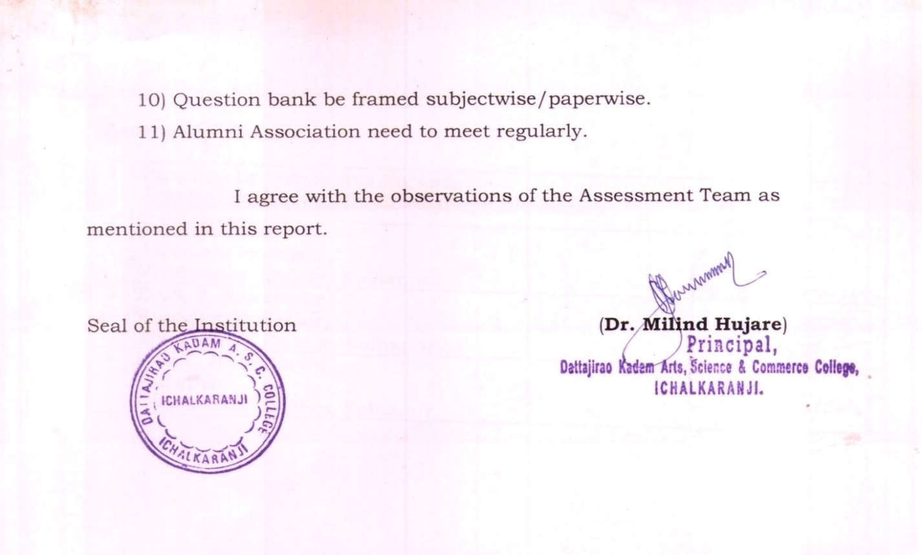

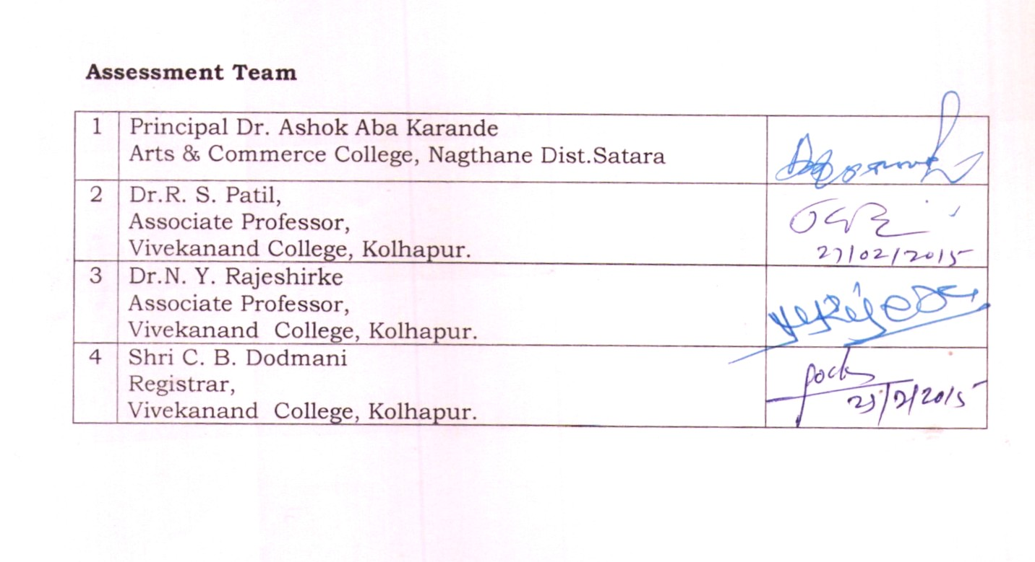

**ANNEXURE - IV**

COMPLIANCES REPORT

Compliances regarding Suggestions made by Mahavidyalayin Vidya Samiti Visited College for Administrative and academic Audit (academic year **2014-2015**) : visit on 27th Feb.2015.)

For Internal Adminstrative and academic audit of the college for the academic year 2014-2015. Hon’ble Chairman and the members of the committee visited college on 27.02.2015. The committee after the interaction with the Hon’blle Principal, faculty and administrative staff, have made certain suggestions and highlighted some **Weaknesses, Opportunities, Challenges** and **recommendations** to the college. The compliances regarding the same are as follows.

**I***.* **Weaknesses of the College :-**

**1. Less no. of P.G. Departments:** At present only M.A.(Hindi & Marathi) courses are run as P.G.(Theory). Due to lack of infrastructure available with the college, at present P.G. Courses in Science stream cannot be started. Instead, P.G. Course by research (M.Phil./Ph.D.) is newly started since 2012 in the subject-Botany.

**2. No separate play ground :** College does not possess owned playground but all the sport events/practice is done on hiring the playgrounds within the city. However good number of students achieved prizes at State/University/Inter Zonal/Zonal level in Volleyball, weight lifting , marathon ,Body building.

**3. Some faculty not involved in active research at all :** College has good potential for research among the 45 senior faculty 17 are with Ph.D. and 8 with M.Phil. and 12 are research guides for M.Phil. and Ph.D. 35 students are registered for Ph.D. and 08 for M.Phil. degree.

At present 2 students were awarded Ph.D. degree and one with M.Phil. degree one have submitted Ph.D.Thesis. Out of remaining 31 faculty, 13 faculty have registered for Ph.D. degree. Two minor research projects are completed; three are ‘ongoing’ while four minor research projects are submitted to UGC by faculty. Up till now fifty six research papers are published by faculty in the academic year in national/international journals and Proceedings with ISBN numbers.

Five faculty have 27 publication of books (to their credit) with ISBN number. Three proceedings of conferences are published in ***Manchester*** Research Journal published by college..

College at present have recognized research laboratory in Botany for M.Phil. and Ph.D. however college have decided to have recognition for Physics and Zoology for M.Phil. and Ph.D. in academic year 2016-2017.However faculty in physics and Zoology have recognition for Ph.D. Few faculty in Marathi, Hindi, English, Botany, Zoology, Physics and commerce are recognized research guides for M.Phil. and Ph.D.from other universities.

However, remaining faculty will be encouraged for research in respective subjects.

**4. Vacant posts in non-teaching in the College:-**

The Communication about the information regarding vacant posts in non-teaching staff is done time to time. The management take the decision for the same as per University & Government rules.

**5. Labs. be equipped and increased keeping in mind the increasing strength :-**

Since this college is unique college in surroundings of Ichalkaranji city, having courses in Arts, Science and Commerce with junior and senior wings.

As far as the present strength of the Jr. & Sr. Science is concerned, the time-table for all the batches are very carefully scheduled in the available laboratories & Classrooms. But due to unavailability of the space, college cannot enhance the infrastructure besides the existing one. However, as per the demand and availability of funds, laboratories are equipped.

**6. Training and faculty members to make them acquainted with modern equipment/technology/internet :**

As far as equipments are concerned the existing laboratory assistants were well experienced for handling them while most of them have substantial knowledge regarding use of Internet as almost all laboratories have this faculty.

**II Challenges to the College :-**

**1)** Start more P.G. Courses :

At present only Hindi & Marathi P.G.Courses & M.Phil./ Ph.D. in Hindi, Marathi, English, Commerce; Physics, Botany, Zoology are run by college.

Due to insufficient infrastructure, at present college is unable to start P.G.Courses in most of the subjects.

**2)** Start add on courses of UGC and University in Social Sciences and Commerce stream.:

As far as Add on courses are concerned, two proposals were submitted in the last year. ( Integrated pest management, and soil water and food analysis),but these were not sanctioned. The proposal for ‘Community College’ has been sent to UGC. in textile designing. However incoming academic year proposals will be sent in social sciences and Commerce for financial assistance.

**3)** Organisation of Conference/seminar/workshop at least two every year :

In this academic year four proposals for national conferences are sanctioned, of which National Conference in Physics, Hindi and History are organized by college and conference in English will be held in Sept.2015.

In the coming academic year proposals for national conference in Marathi, Geography,Commerce,Economics and Sociology will be sent to UGC for financial assistance.

**4)** To promote Research Culture **:-** It is fact that, college faculty have good potential for research as it can be seen from the number of research guides (12) and research papers published(56). Eventhough, research promotion cell will encourage the remaining faculty for getting involved in research and publications.

**5)** To make alumni active and participative :- In coming academic year, alumni meet will be held for their active participation for college development and progress.

**6)** Decreasing strength of B.B.A. Course:-

As far as the strength of B.B.A. course is concerned, within the affiliated colleges the strength is declining.With the reference to recommendations received from Sanstha’s audit section. College have decided to close this course from the next year, as college has to face the fincncial problems for payment of faculty due to lack of sufficient students and fees availability.

**7)** To increase co-curricular activities:-

Faculty is involved in completion of syllabi of all subjects within semester pattern, eventhough they are involved in organising co-curricular activities. However, all of the faculty timely engaged in organizing seminars, questionnaire, MCQ, surprising test, unit tests, home assignments, project activities, open book test, oral test, quiz like activities. As far as the results are concerned , it seems that, all of the courses have achieved more than 90% passing in the last year with good number of students achieved first class and distinction.

**III) Opportunities of the College**:-

1. Start P.G. Courses **:** Besides the existing P.G.Courses, college may think about the granting permission for more P.G.Courses in Commerce and Sociology. But within the availability of existing infrastructure and insufficient faculty it may not be possible to run Ph.D. Course in Sociology.
2. Start Add on courses of UGC and University :- Explaination as in II (2)
3. Organisation of Conference/Seminar/Workshop at least two every year:

Explaination as in II (3)

1. Increase no. of MRP & COC.:

Research promotion cell will encourage the faculty for MRP/COC courses in the next year.

1. Starting short term courses in commerce:

IQAC of the college may call a meeting for starting short term courses in commerce and decision will be taken regarding the same.

**IV) Recommendations for Quality Enhancement of the College:**

1. At least two National level Seminars/Workshops/ Conference be organized every year:

Research promotion cell and IQAC will encourage the departments to send proposals for the same for financial assistance from UGC.

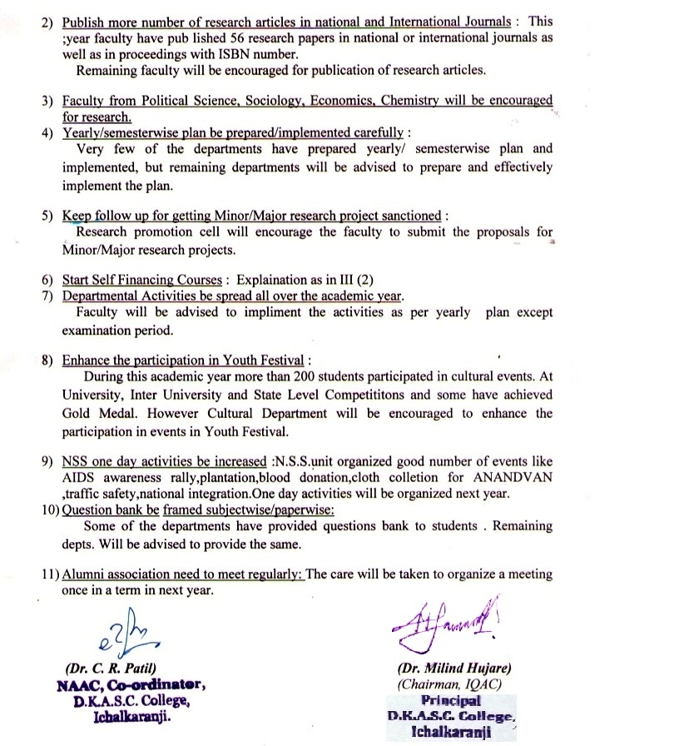

**ANNEXURE - V**

**ACHIEVEMENTS**

**Cultural:**

|  |  |  |  |  |  |
| --- | --- | --- | --- | --- | --- |
| **Sr. No.** | **Particulars** | **No. of Students participated** | **Venue** | **Collegiate / State / University Level** | **Rank / Award / Prizes/ Statu** |
| 1 | ADD ACT and Poster Presetation | 06 | Sangli, Kolhapur | Inter Collegiate | Rank - First |
| 2 | Tribal group dance sports dance asso. | 10 | Kolhapur, Amaravati | District / State Level | Rank - First  Gold Medal |
| 3 | Short play Bharatiyam Trophy, Pune | 06 | Kadegaon, Sangli | District Level | Rank - First |
| 4 | Avishkar | 01 | Aurangabad | State Level | Runner Championship |
| 5 | Group Song | 06 | Hatkanangle | State Level | Third |
| 6 | Group Dance | 27 | Ichalkaranji | State Level | 2nd Rank |
| 7 | Solo Dance | 27 | Ichalkaranji | State Level | 3rd Rank Encourage Award |
| 8 | Short Play | 27 | Ichalkaranji | State Level | 2nd Rank |
| 9 | One Act Play | 27 | Ichalkaranji | State Level | 3rd Rank (6-10) General Compionship |
| 10 | Delsate | 02 | Kolhapur Murgud Warnanagar | Inter Collegiate  Inter Collegiate | First Rank |
| 11 | Quiz Shivaji University Statistics Association | 04 | Kolhapur | Inter Collegiate | Gold Megal |
| 12 | Drawing S.M.Bapuji Salunkhe Competition Painting | 05 | Kolhapur | State Level | First Rank |
| 13 | Drawing S.M.Bupuji Salunkhe Competition Painting | 05 | Kolhapur | State Level | Third Rank |

**SPORTS**

|  |  |  |  |  |  |
| --- | --- | --- | --- | --- | --- |
| **Sr. No.** | **Player's Name** | **Class** | **Event** | **Level** | **Place** |
| 1 | Chavan Priyanka Kumar | T.Y.B.A. | V.Ball | Inter Uni. | Aurangabad |
| 2 | More Maya Baburao | T.Y.B.A. | V.Ball | Inter Uni. | Aurangabad |
| 3 | Datar Dhanashri | F.Y.B.A. | Talkondow | All India | Murgud & Chennai |
| 4 | Mayur Barge Rajaram | T.Y.  B.Com. | Weight Lifting | Inter Zone 2nd Place | Shivaji Uni. Shahu Coll. |
| 5 | Sathe Dilip Gunda | F.Y.B.A. |  | Inter Zone 3rd Place | Shivaji Uni. Shahu Coll. |

|  |  |  |  |  |  |
| --- | --- | --- | --- | --- | --- |
| 6 | Mokote Akash Ananda | F.Y.B.A. | Body Building | Inter Zone 2nd Place | Shivaji Uni. Shahu Coll. |
| 7 | Thombare Thakurbharat Rajaram | F.Y.B.A. | Body Building | Inter Zone 3rd Place | Shivaji Uni. Shahu Coll. |
| 8 | Kesarkar Amit Sadashiv | T.Y.B.A. | Marathon | State Level | Pune & Satara |
| 9 | Kakade Sumersing Jalinder | F.Y.B.A. | Judo | State Level | Nandurbag |
| 10 | Bairagi Swati Dhandaj | T.Y.B.Sc. | V.Ball | Inter Zone 1st Place | Halkarni & Jaysingpur |
| 11 | Chavan Pallavi Sunil | T.Y.B.Sc. | V.Ball | Inter Zone 1st Place | Halkarni & Jaysingpur |
| 12 | Nippane Archana Sambhaji | T.Y.B.Sc. | V.Ball | Inter Zone 1st Place | Halkarni & Jaysingpur |
| 13 | Chavan Sadna Tanaji | S.Y.B.A. | V.Ball | Inter Zone 1st Place | Halkarni & Jaysingpur |
| 14 | Kawale Mokshanda Vijay | F.Y.  B.Com. | V.Ball | Inter Zone 1st Place | Halkarni & Jaysingpur |
| 15 | Mestri Afarin Firoj | F.Y.B.Sc. | V.Ball | Inter Zone 1st Place | Halkarni & Jaysingpur |
| 16 | Lipare Sonali Bhushan | F.Y.B.Sc. | V.Ball | Inter Zone 1st Place | Halkarni & Jaysingpur |
| 17 | Faras Mimaj Makabul | F.Y.B.Sc. | V.Ball | Inter Zone 1st Place | Halkarni & Jaysingpur |
| 18 | Patil Tejasvini | F.Y.B.Sc. | V.Ball | Inter Zone 1st Place | Halkarni & Jaysingpur |
| 19 | Bairajdar Rukaiya Rashid | S.Y.B.A. | V.Ball | Inter Zone 1st Place | Halkarni & Jaysingpur |
| 20 | Germal Manovati Sagar | F.Y.B.Com. | V.Ball | Inter Zone 1st Place | Halkarni & Jaysingpur |
| 21 | Mujawar Sanika | F.Y.B.Com. | V.Ball | Inter Zone 1st Place | Halkarni & Jaysingpur |

**CURRICULAR**

1. **QUIZ**

One 1st rank four districts and one 2nd rank in four districts in Shivaji University statistic Teachers Association organized Quiz competition. Rank Holders in SUSTA Quiz.

University Rank Holder - M.A. Hindi - first

1. **Student Academic Placements** 
   1. Short services Board - 7 selected; 9 students selected for M.Sc. Chemistry; 3 students for M.Sc. Botany.
   2. 1st Rank for Best Article writing in 'Vivek' magazine and 2nd rank to one student for Best article writing in 'Vivek' magazine by University.
   3. 1st Rank and 3rd rank in drawing competition.
2. **N.S.S.**
3. 4 students, one faculty selected for Para legal volunteer Induction course.
4. One volunteer selected for National Integration Camp at State level.

**4) N.C.C.**

i) R.D. Parade - New Delhi - 1 Cadet selected

ii) NIC Camp - 1 Cadet selected

1. Army Attachment Camp - 4 cadets selected
2. Republic Day Pared - at Municipality - 1st prize
3. One Best cadet selection at - TSC, New Delhi
4. 2- Cadets selected in TSC Camp, New Delhi.

14 - Cadets achieved 'B' Certificates.