**Group Discussion 2021-22 (B.Sc.II)**

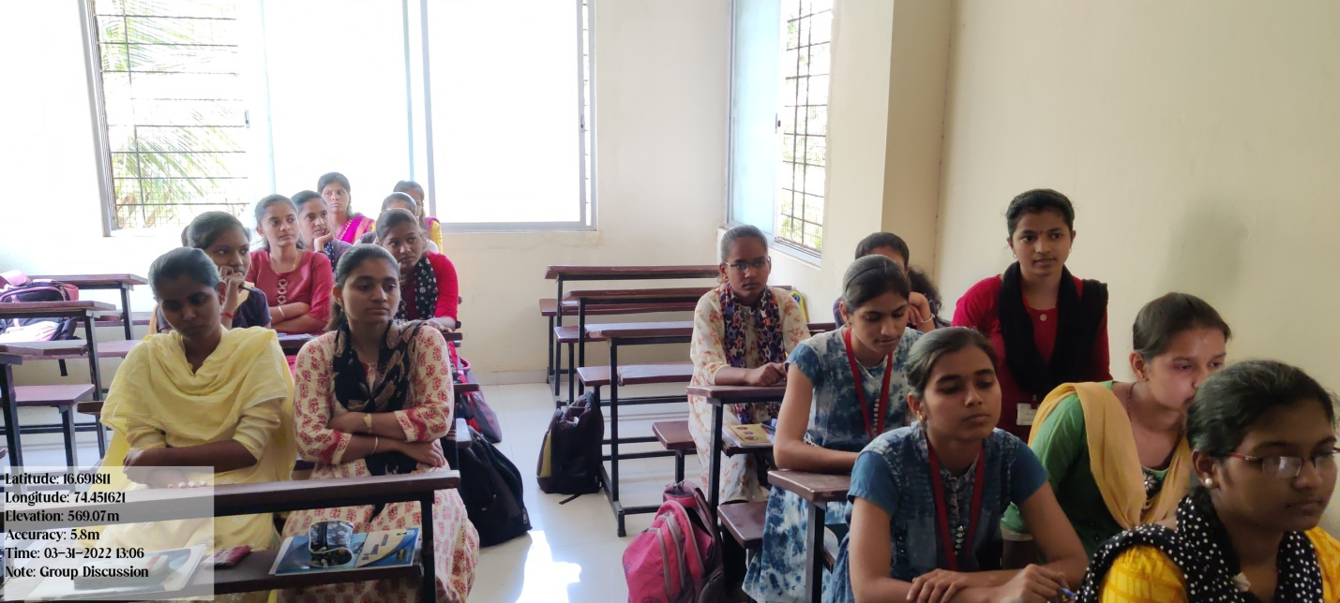

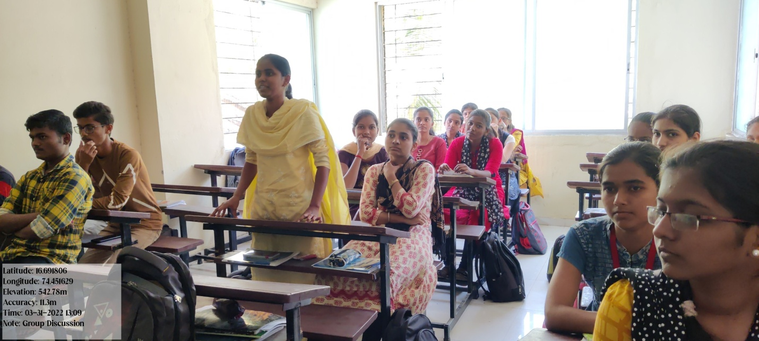

**ICT Based Teaching 2021-22**

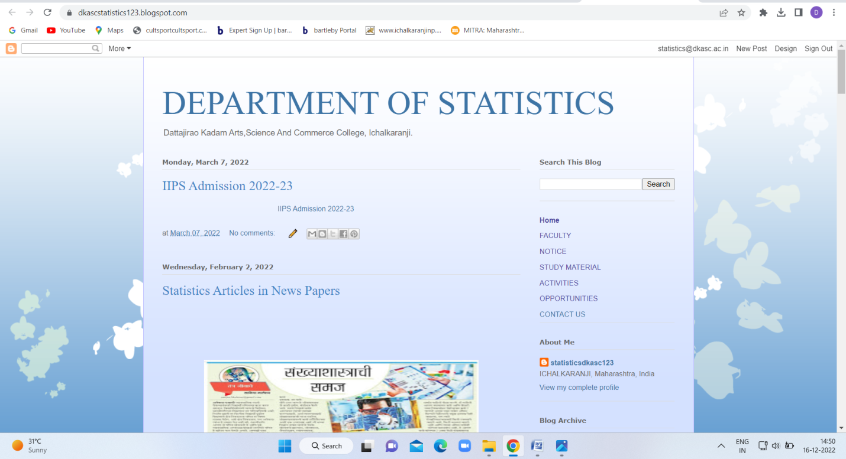

Departmental blog <https://dkascstatistics123.blogspot.com/>

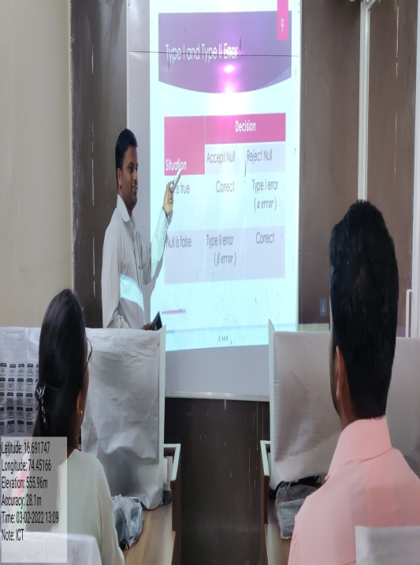 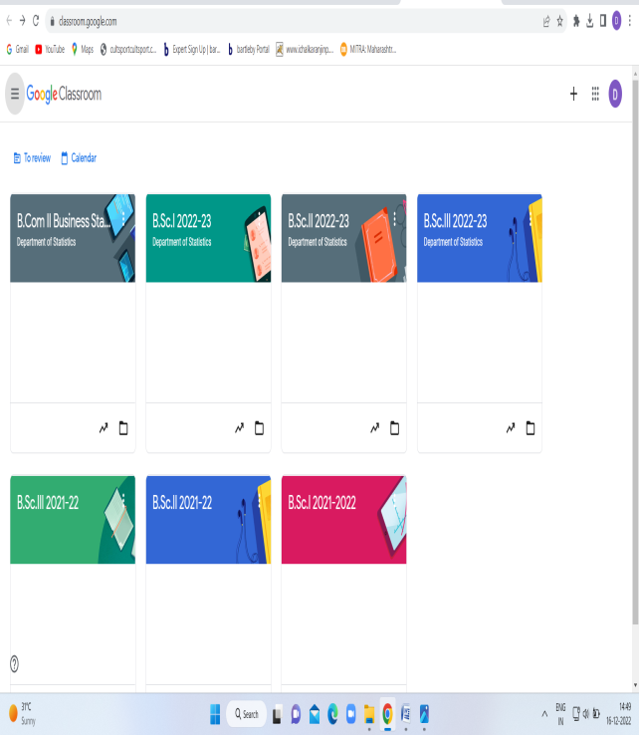

**PPT Presentation Google Classroom**

**Departmental Inauguration Function 2021-2022**

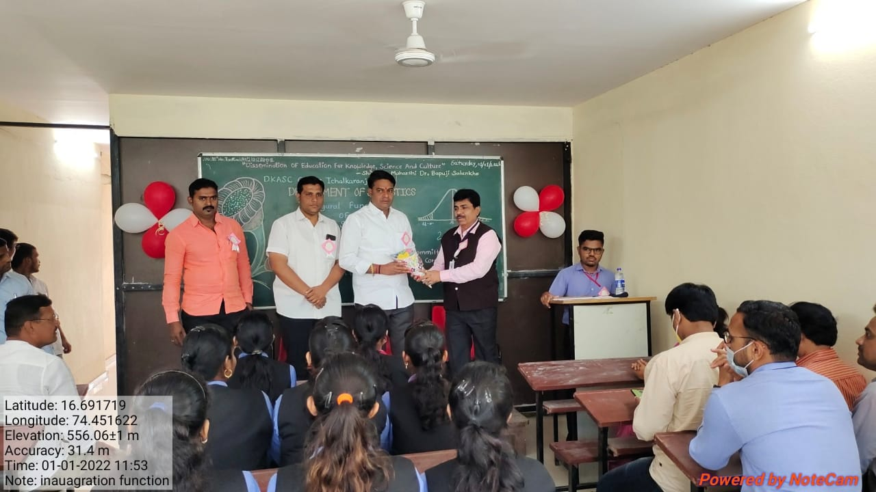

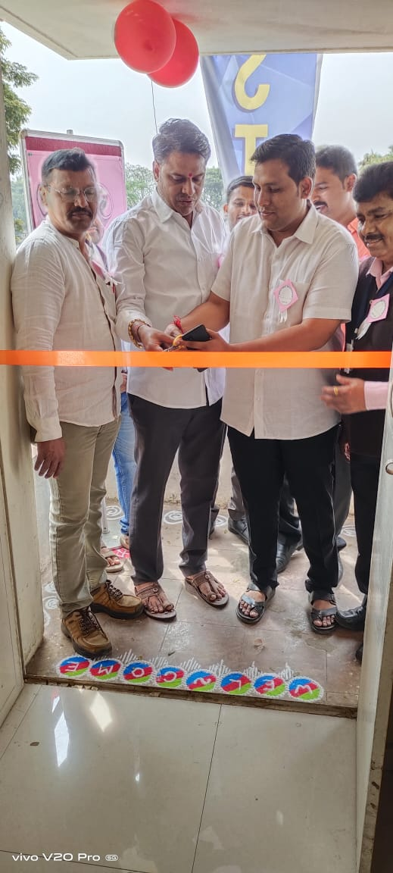

**POSTER PRESENTATION 2021-22**

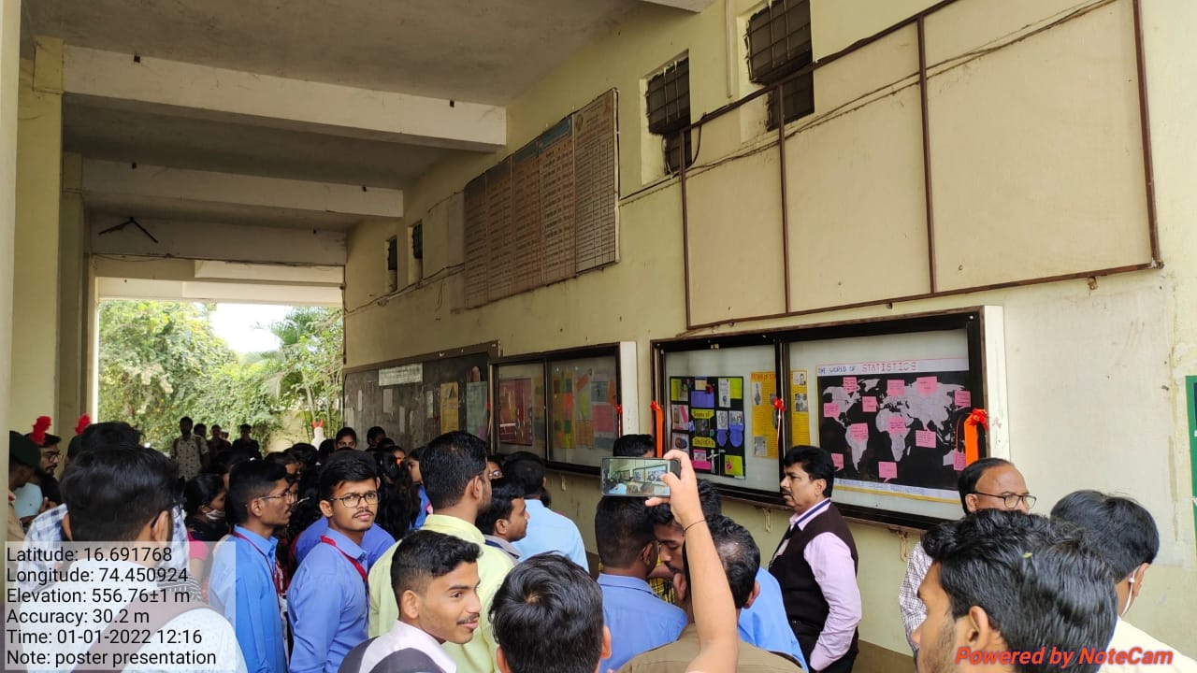

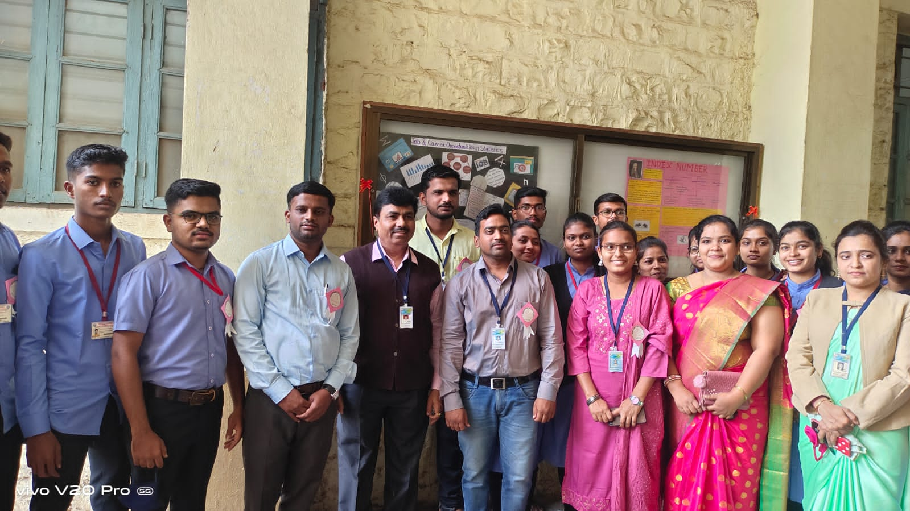

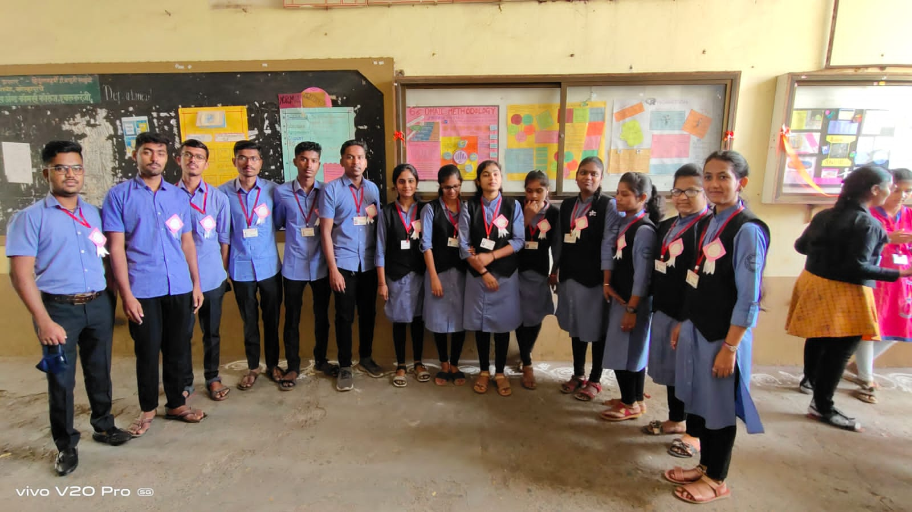

**BRAIN STORMING 2021-22 (B.Sc.II)**

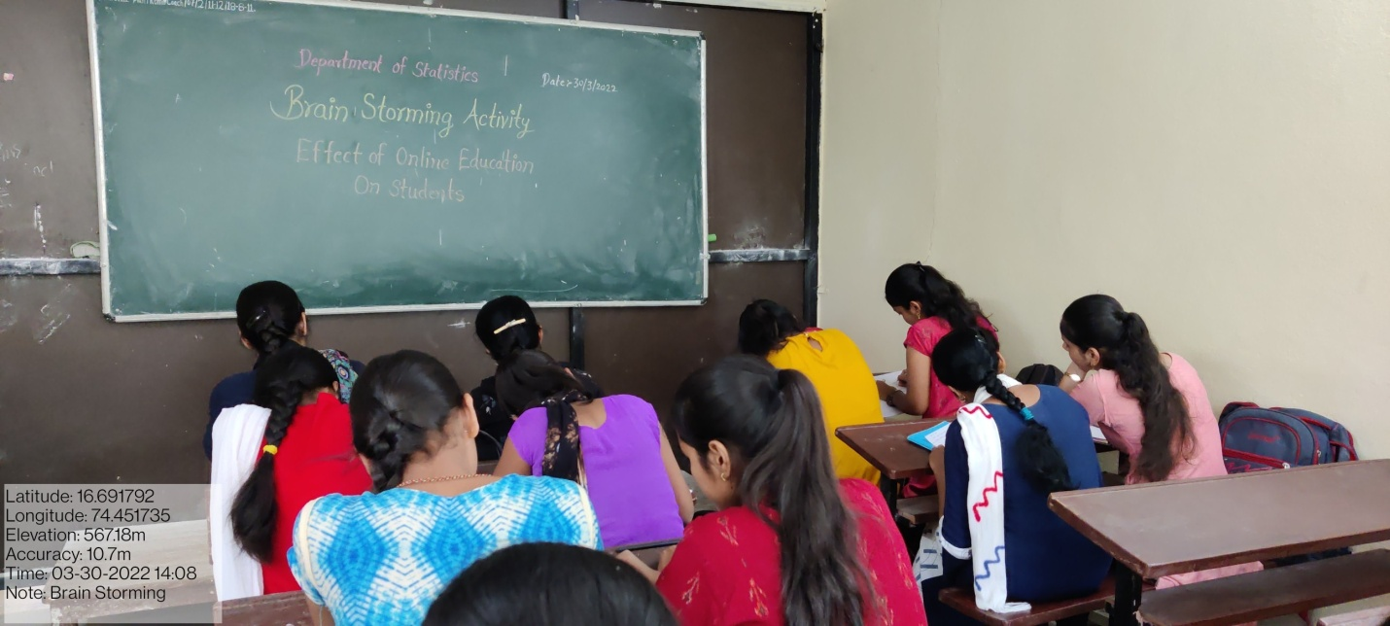

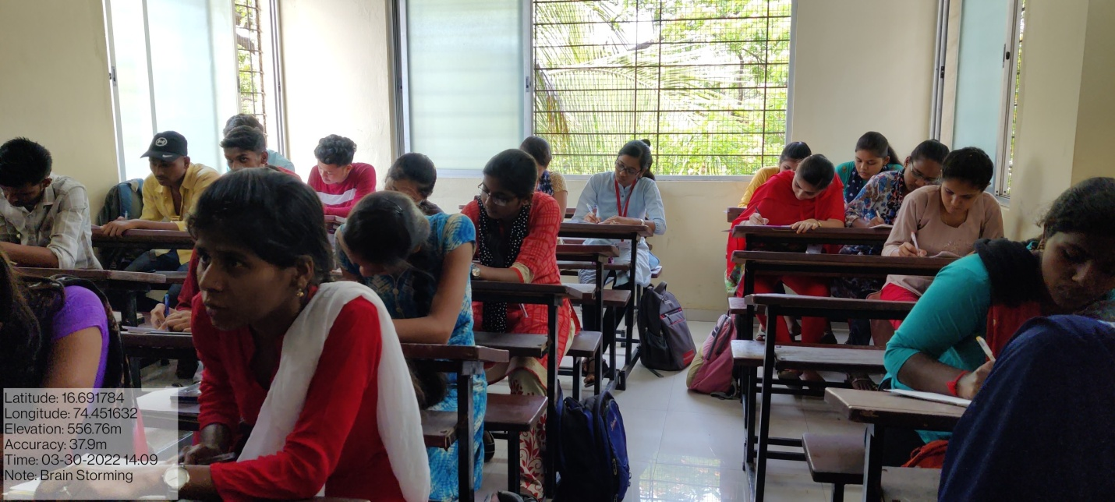

**BRAIN STORMING 2021-22 (B.Sc.III)**

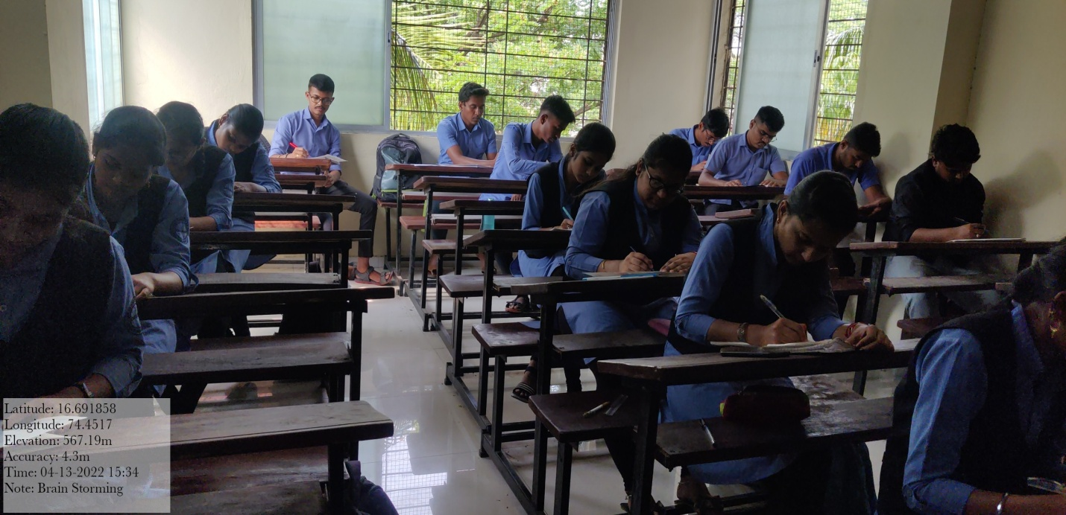

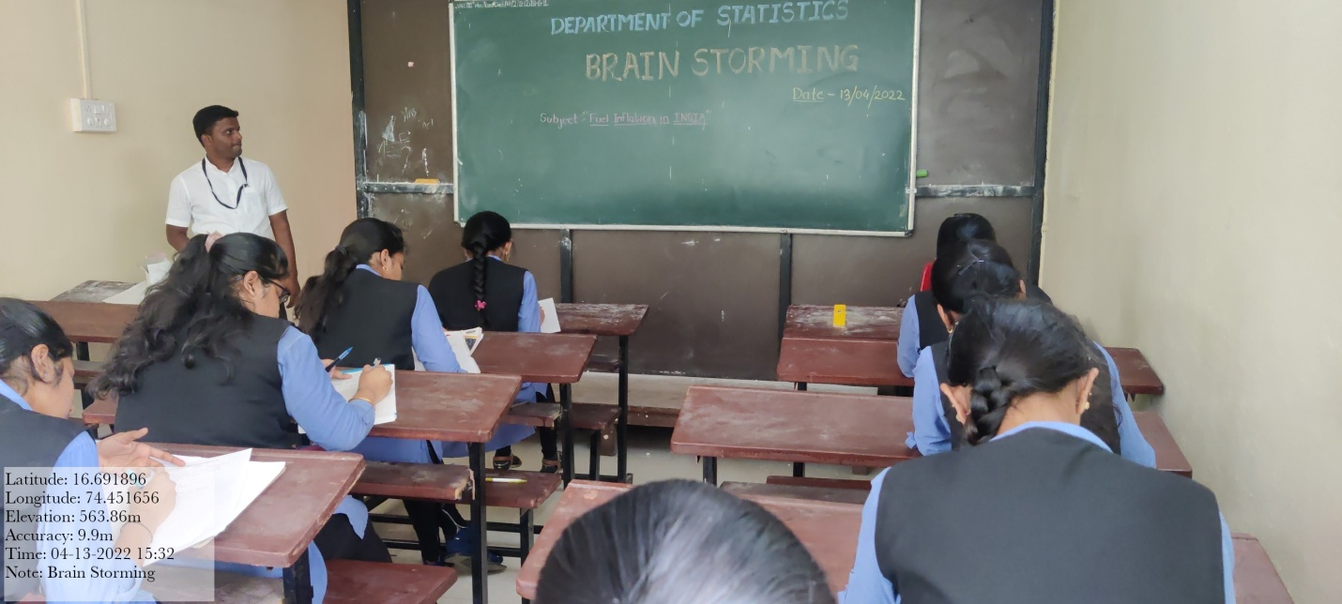

**FAREWELL-FUNCTION 2021-22 (B.Sc.III)**

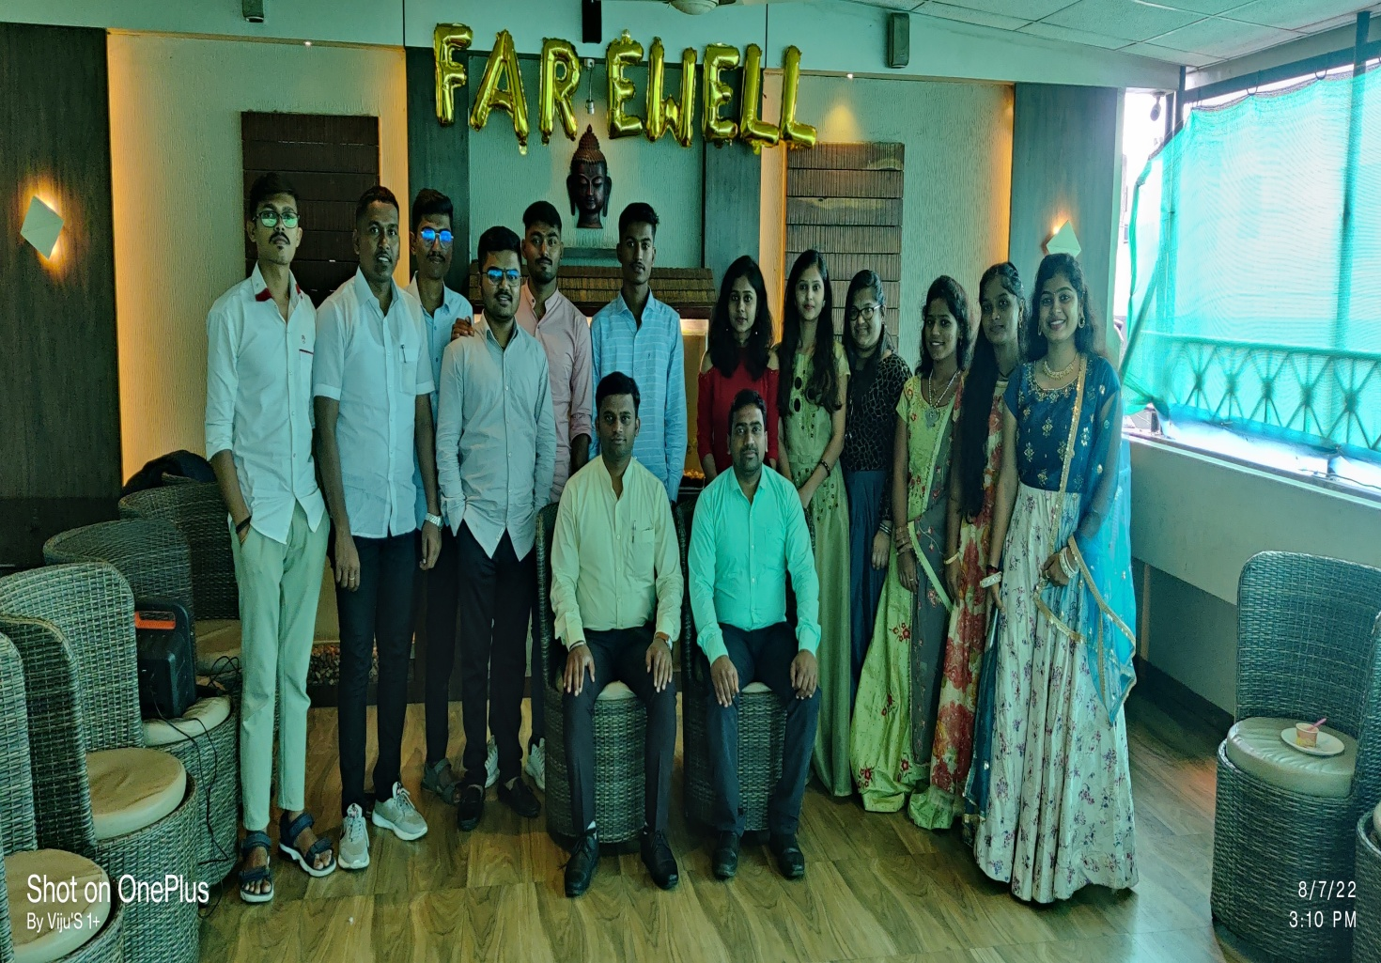

**STUDY TOUR 2021-2022**

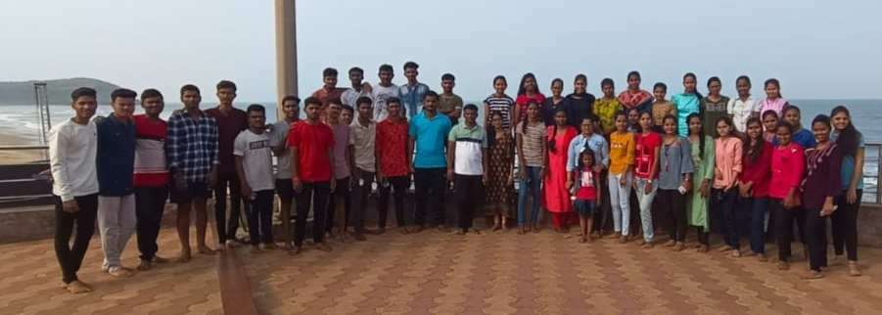

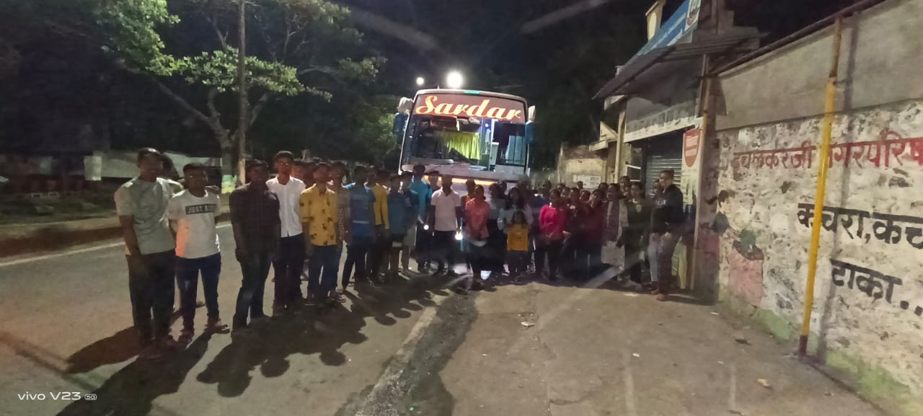

**GUEST LEACTURE 2021-2022 (NATIONAL STATISTICS DAY)**

