One day Workshop on “APPLICATIONS OF STATISTICS” 31st March 2023
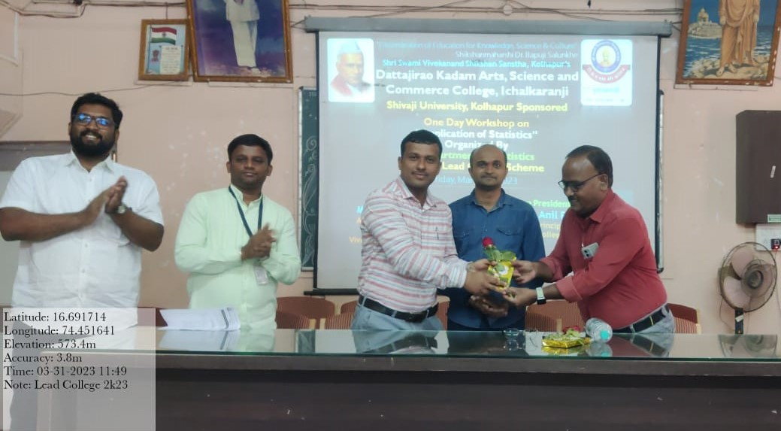

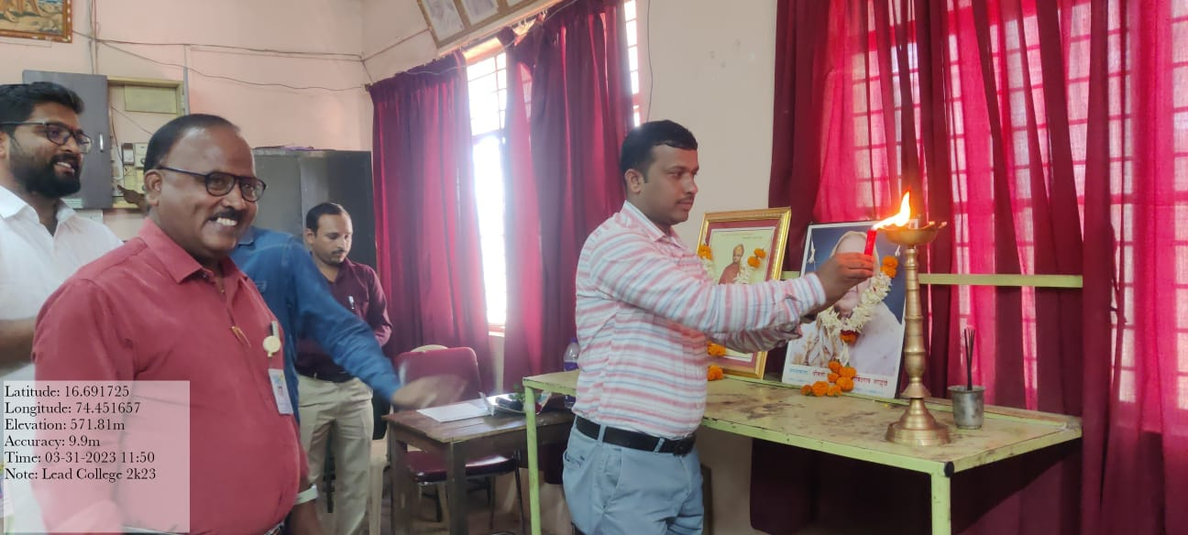

Study Tour (Department of Bio-statistics, Bharati Hospital & Medical college, Sangli.)
25th March 2023

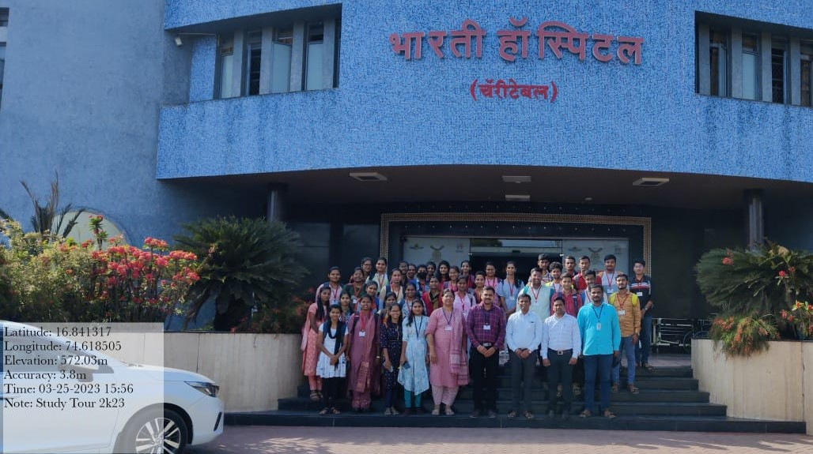

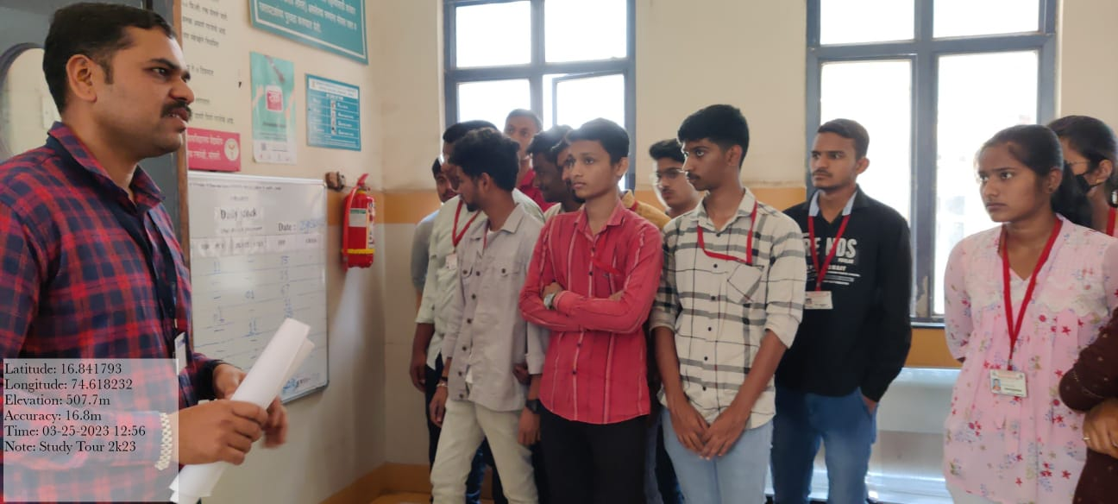

Seminar for B.Sc-III year students. 23rd March 2023

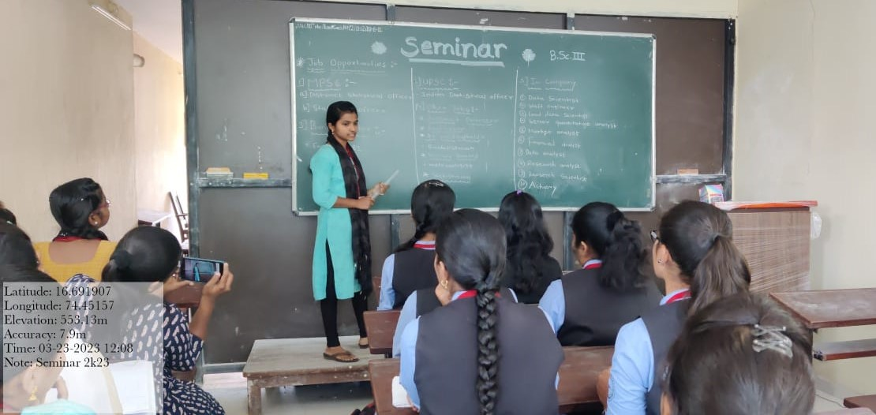

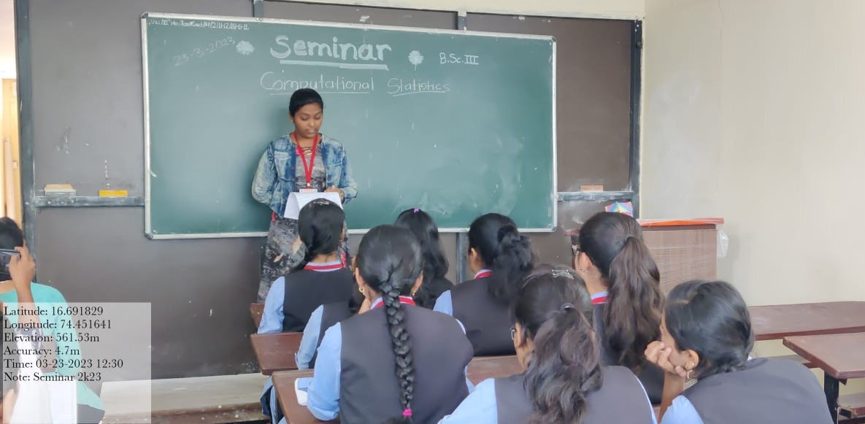

Guest Lecture for all Statistics Students on “Applications of Statistics” 19th may 2023
