**DATTAJIRAO KADAM ARTS, SCIENCE AND COMMERCE COLLEGE, ICHALKARANJI**

**CULTURAL REPORT (2018-19)**

**Dr. D. C. Kamble**

**Chairman, Department of Cultural**

The academic year of 2018-19 cultural Department strongly participate in cultural events and do the drastic change. In this year total 35 boys and girls participated in Shivaji University, Kolhapur Central Youth Festival Competition 2018-19 and wined 5th group and individual events as like Folk Dance 2nd, Group Instolation 2nd, Spot painting 1st, Rangoli 1st, Western Solo Instrumental 2nd this is special achievement of cultural Department.

In this year our college Culture department team participated and owned Prize in C.M. Corandak, Ichalkaranji Rs. 20000/-, National level All India Dance Championship, Chiplun 20000/-, State Level Kamgar Kalyan Mandal 10000/-, Youa Spandan Ichalkaranji, Rs. 10000/-, Youak Biradari, Aitvade Khurd, 1st Prize, Pandharpur Dance Championship, One act Play Atigre 1st Prize, CSIBER College, Kolhapur Group Dance 2nd, Vasant Karandak 2019 organized by Dr. P. V. P. Institute of Technology, Budhgaon we owned the General Championship, owned Vibrant Dance Championship Ghodavat University, Atigre, Participate and present the various events in Agricultural Exhibition, Ichalkaranji organized by Ministry of agriculture department Maharashtra State Rs. 20000/-. One student represented of Shivaji University to National Level Qavalli Competition 2018-19.

|  |  |  |  |  |  |
| --- | --- | --- | --- | --- | --- |
| Year | Name of the award / medal | National / International | Sport / culture | ADHAR/ Student ID number | Student Name |
| 31 Oct. to 2 Nov. 2018 | Youth Fest.  1. Folk Dance 2nd  2. Group Installation 2nd  3. Spot Painting 1st  4. Rangoli 1st  5.Western Solo Instrument 2nd | Uni. Level | Culture |  | Group  Group  Shri. Onkar Shirgupe  Shri. Onkar Shirgupe  Shri. Akash Nandurbarkar |
| 6 Dec. 2018 | CM Chashak, Ichalkaranji  1. Singing 2nd  2. Solo Dance 2nd  3. Group Dance 1st | Maharashtra (State Level) | Culture |  | *Soniya Minikar  *Shruti Babar  Group |
| 26 Dec. 2018 | All India Dance Championship, Chiplun  1. Group Dance | National | Culture |  | Group |
| Jan 2019 | Yuva Spandhan, Ichalkaranji  1. Group Dance 1st  2. Singing Group | State Level | Culture |  | Group  Group |
| Jan 2019 | Yuvak Biradari, Aitvade Khurd  1. Group Dance 1st | State Level | Culture |  | Group |
| 2 Jan. 2019 | Pandharpur Dance Championship  1. Group Dance | State Level | Culture |  | Group |
| 1 Jan. 2019 | One Act Play, Atigre | State Level | Culture |  | Group |
| 4 &5 Feb. 2019 | Csiber College, Kolhapur  1. Group Dance 2nd | State Level | Culture |  | Group |

|  |  |  |  |  |  |
| --- | --- | --- | --- | --- | --- |
| 23 Feb. 2019 | Vasant Karandak  1. Group Dance 1st  2. Street Play 1st  3. Photography 1st | State Level | Culture |  | Group  Group  Shri. Sharad Patil |
| 25 & 27 Feb. 2019 | Vibrant Dance Championship Ghodawat Uni., Atigre  1. Group Dance 1st  2. Photography 1st | State Level | Culture |  | Group  Shri. Sharad Patil |
| 22 & 23 Oct. 2018 | National Inter-Uni. Qawwali Competition 1st | National | Culture |  | Shri. Vishal Swami |
| 19 Jan. 2019 | Agriculture Exhibition | Maharashtra Govt. Agriculture Ministry  State Level | Culture |  | Group Participation |

**Cultural Committee:**

1. **Dr. D. C. Kamble – Convener**
2. **Mrs. S. J. Velhal**
3. **Dr. A. P. Jadhav**
4. **Mr. V. L. Kamble**
5. **Dr. Mrs. P. K. Waghmare**
6. **Mrs. R. S. Rodriques**

**Chairman**

Cultural Department

D.K.A.S.C. College, Ichalkaranji

**Grand Success**

**DKASC College, Ichalkaranji**

**Cultural Department 2018-19**

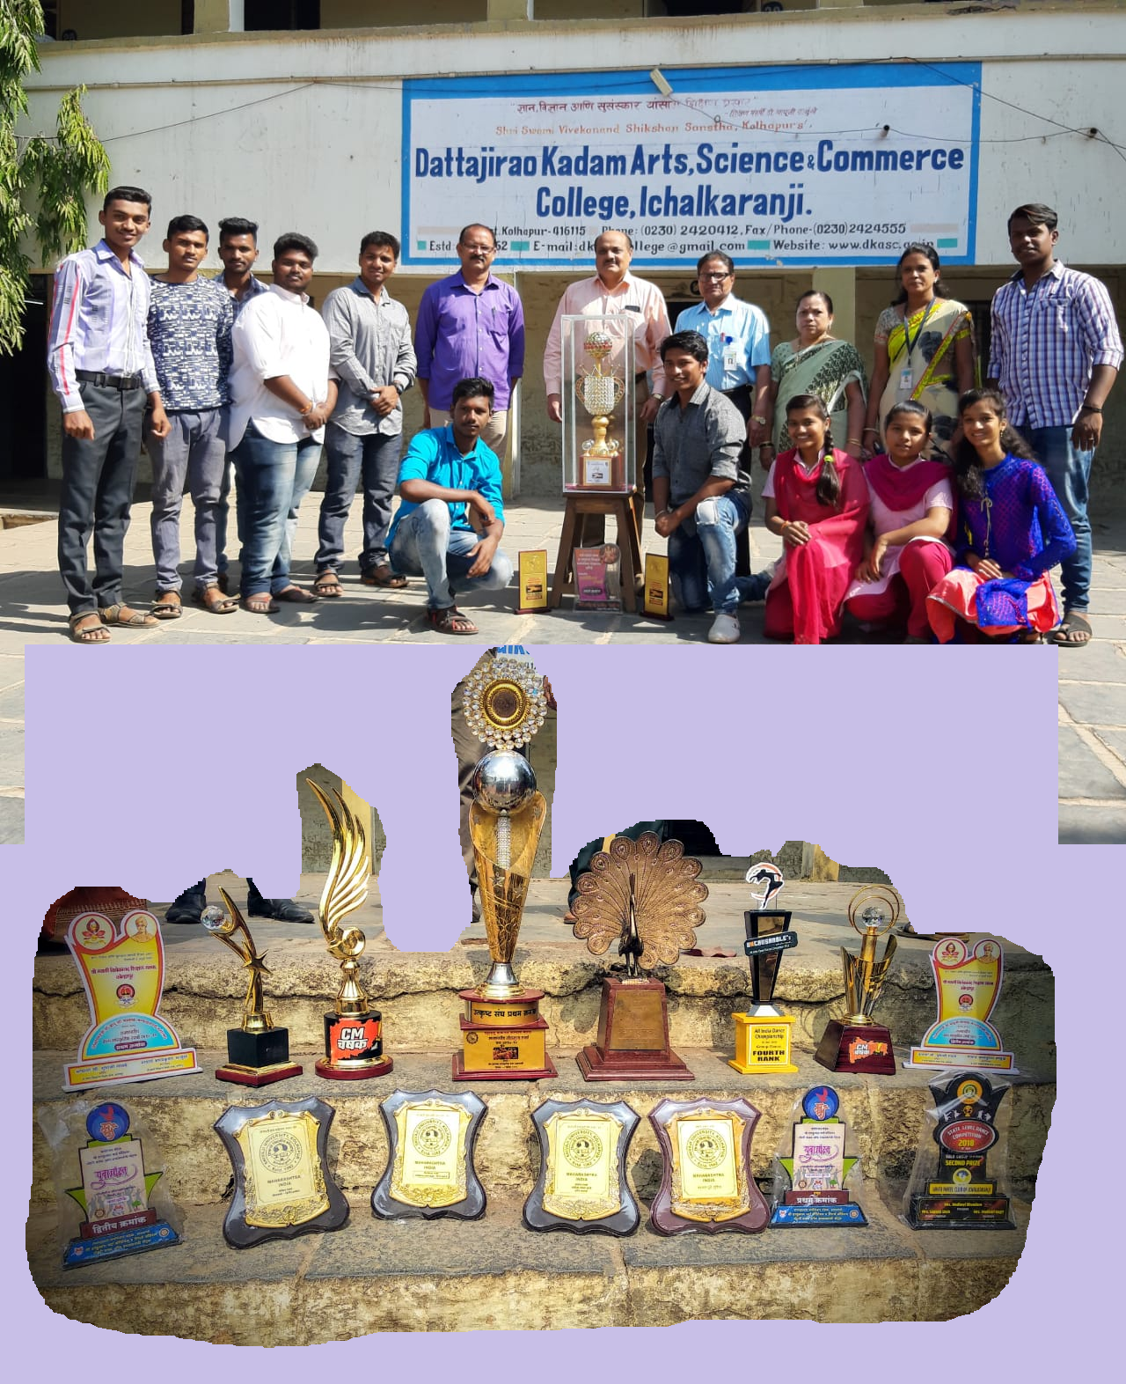

**Chairman: Dr. D. C. Kamble**

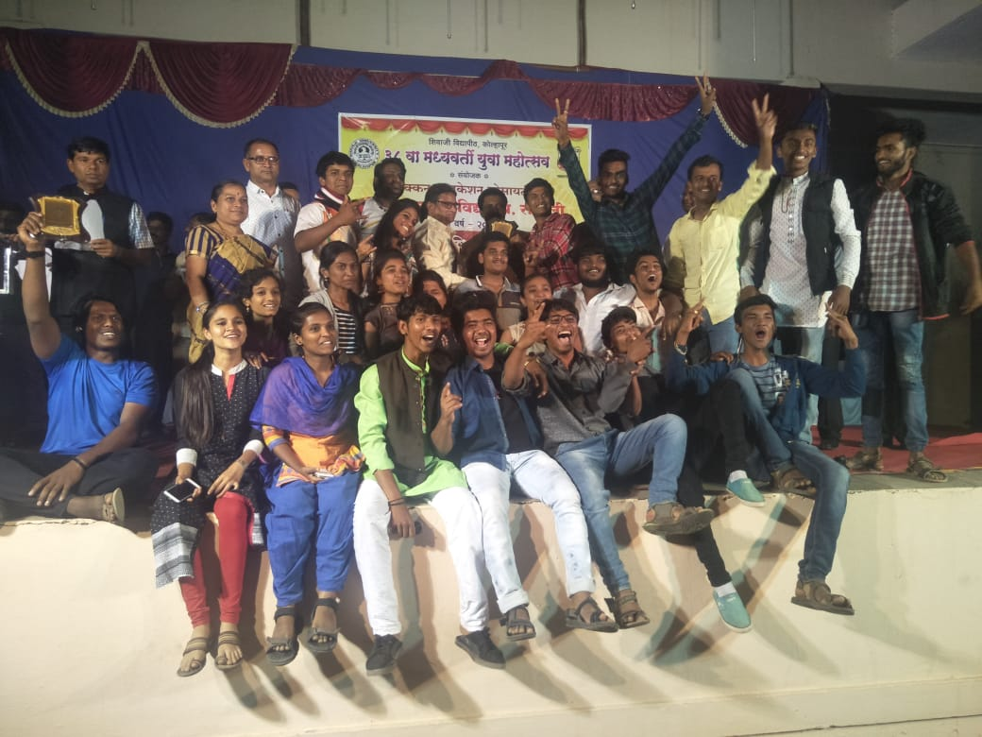

Shivaji University Central Youth Festival, 31 Oct. to 2 Nov. 2018, Success in Folk Dance 2nd, Group Installation 2nd, Spot Painting 1st,, Rangoli 1st,, Western Solo Instrument 2nd

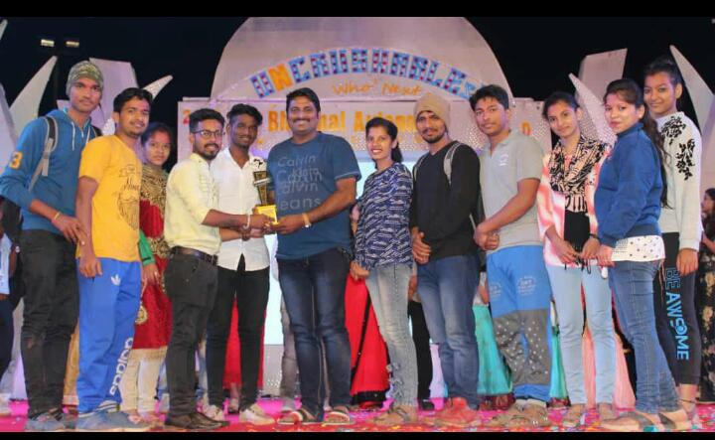

Winner Team of All India Dance Championship, Chiplun, 1. Group Dance, 26 Dec. 2018

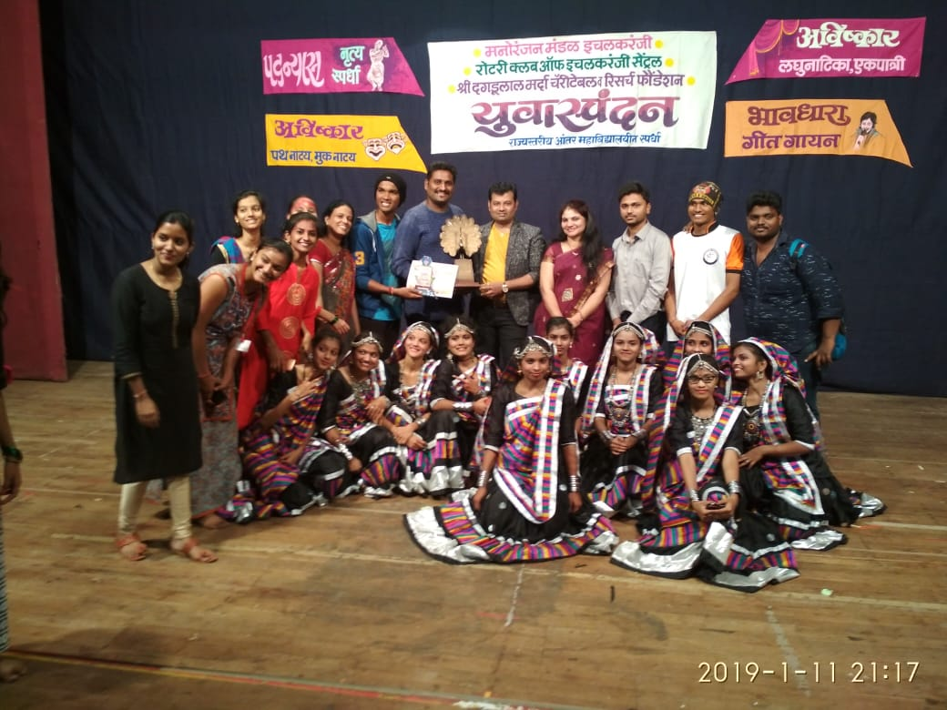

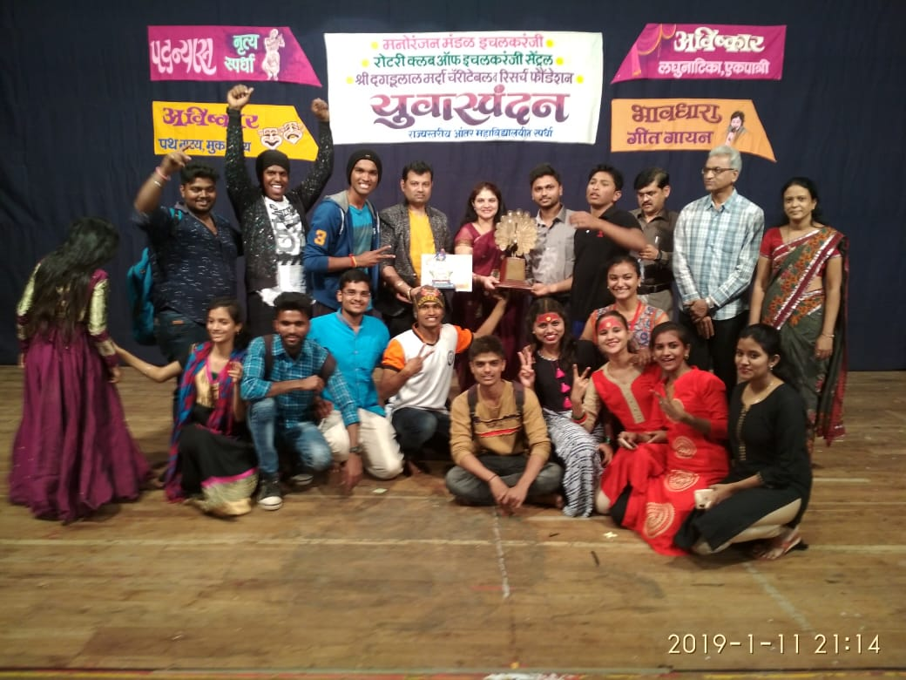

Yuva Spandhan, Ichalkaranji, 1. Group Dance 1st, 2. Singing Group, 11 Jan 2019

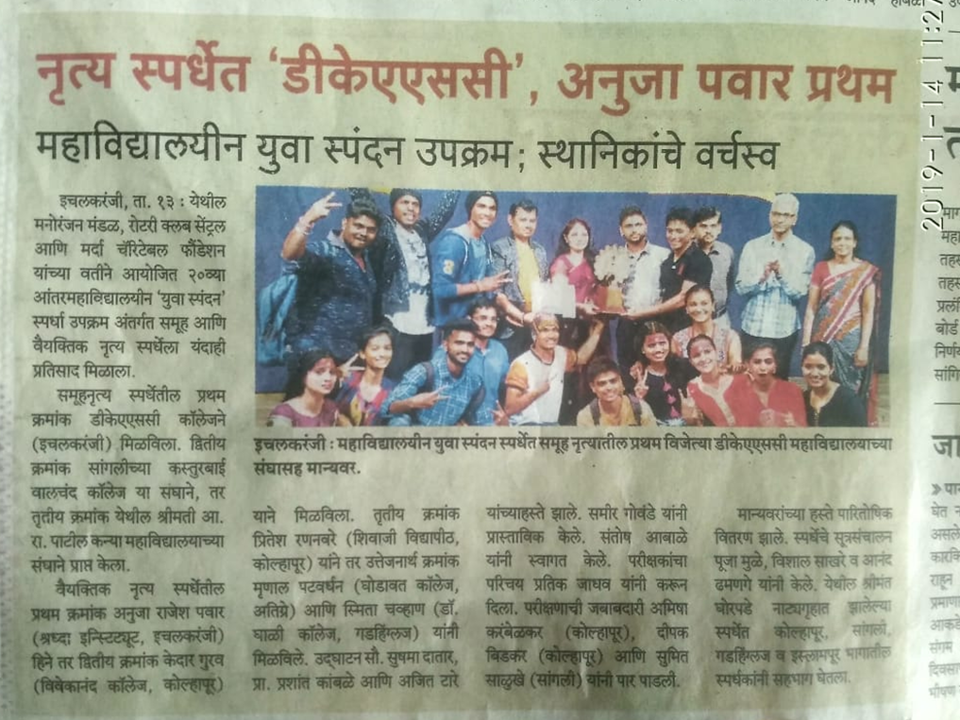

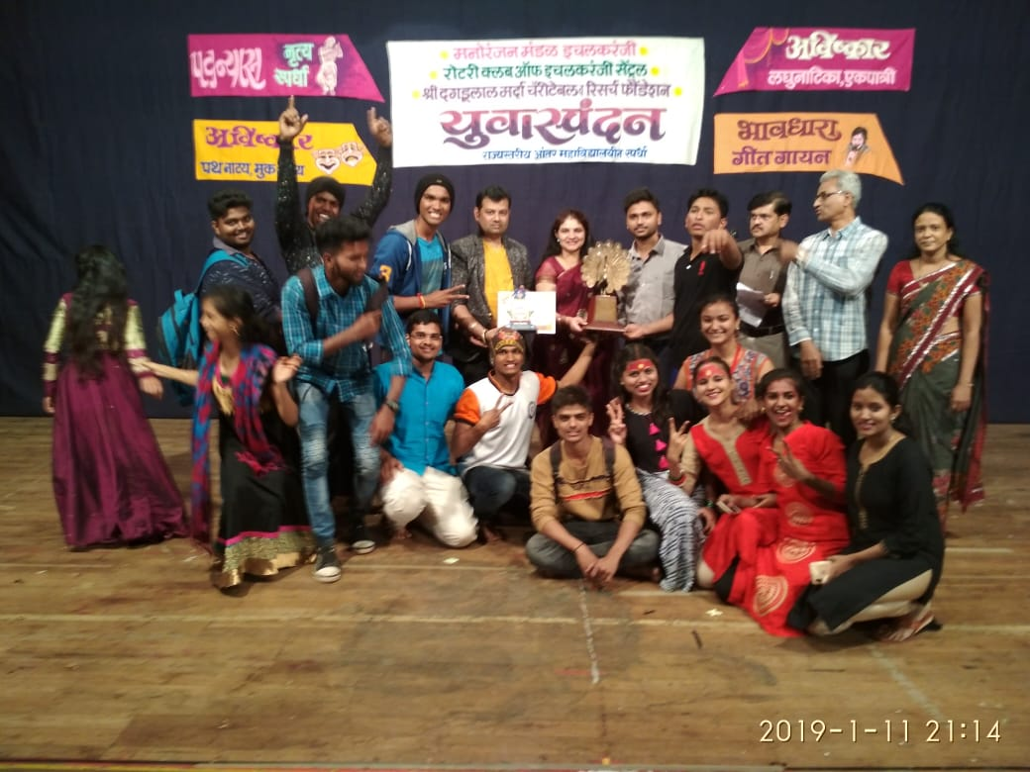

Yuva Spandhan, Ichalkaranji, 1. Group Dance 1st, 2. Singing Group, 11 Jan 2019

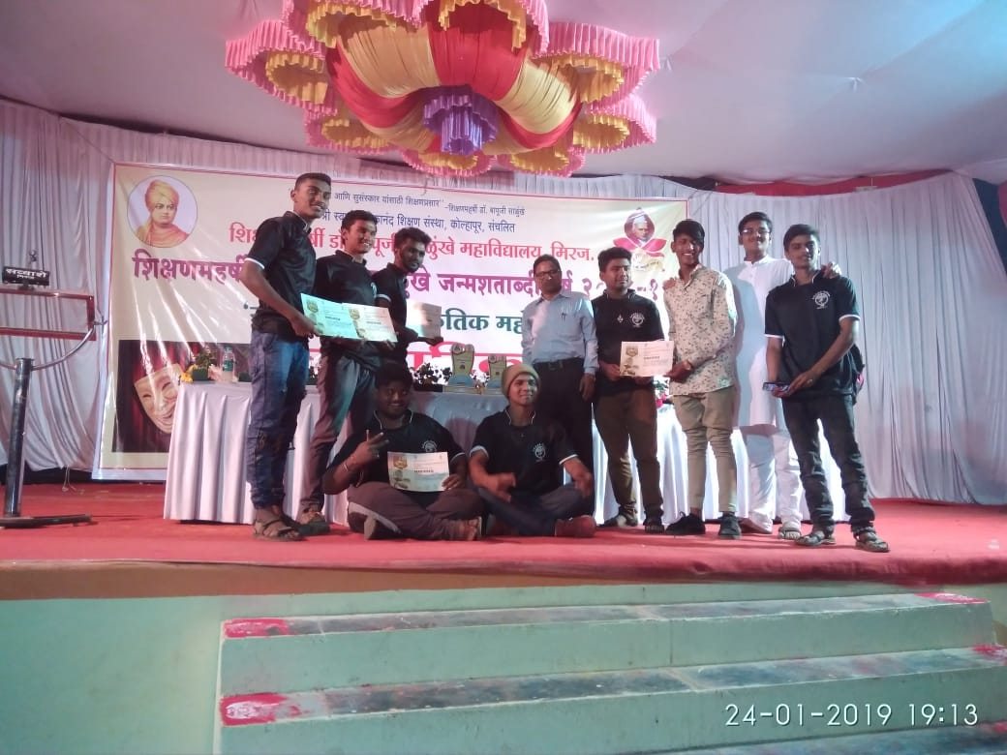

State Level Competition on the Occasion of Birth Anniversary of Shikshanmaharshi Dr. Bapuji Salunkhe, at Shikshanmaharshi Bapuji Salunkhe Mahavidyalaya, Miraj dt. 24/01/2019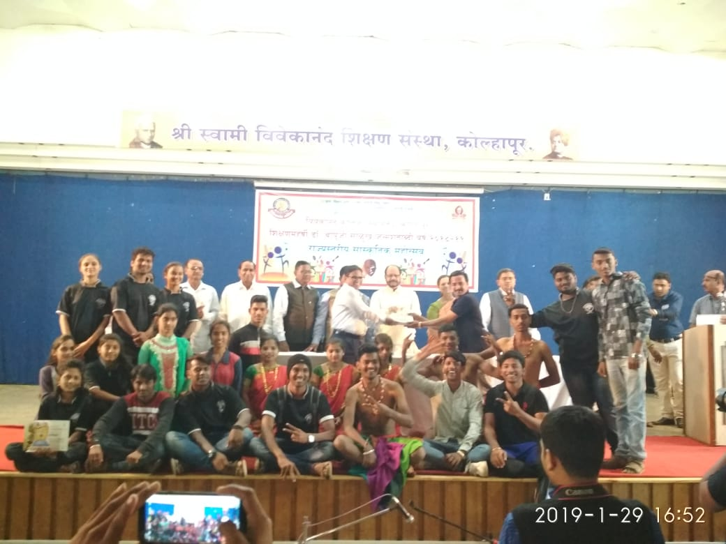

Shikshanmaharshi **Dr. Bapuji Salunkhe Birth Anniversary State Level Cultural Competition at Vivekanand College, Kolhapur 29/01/2019**

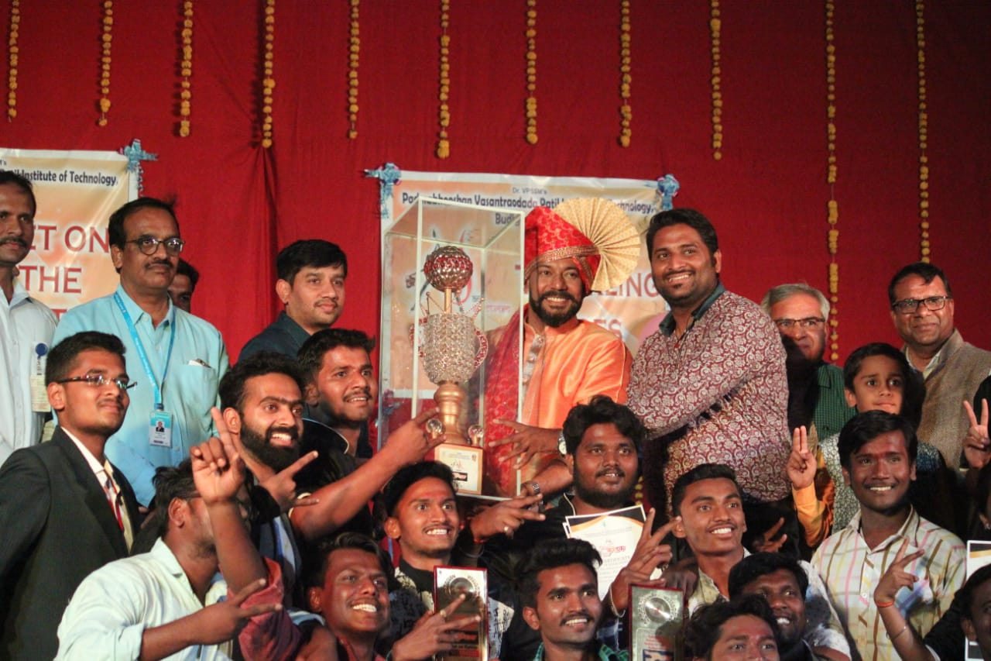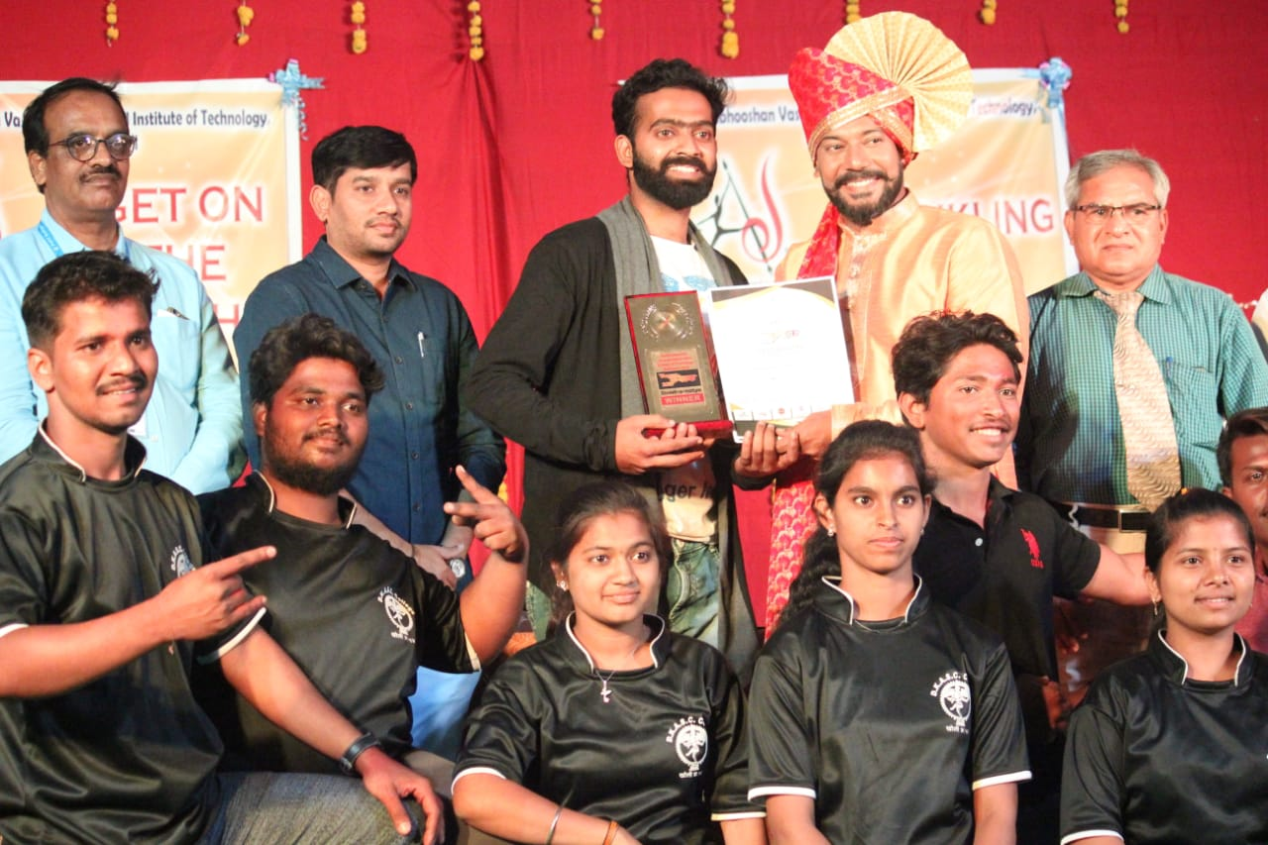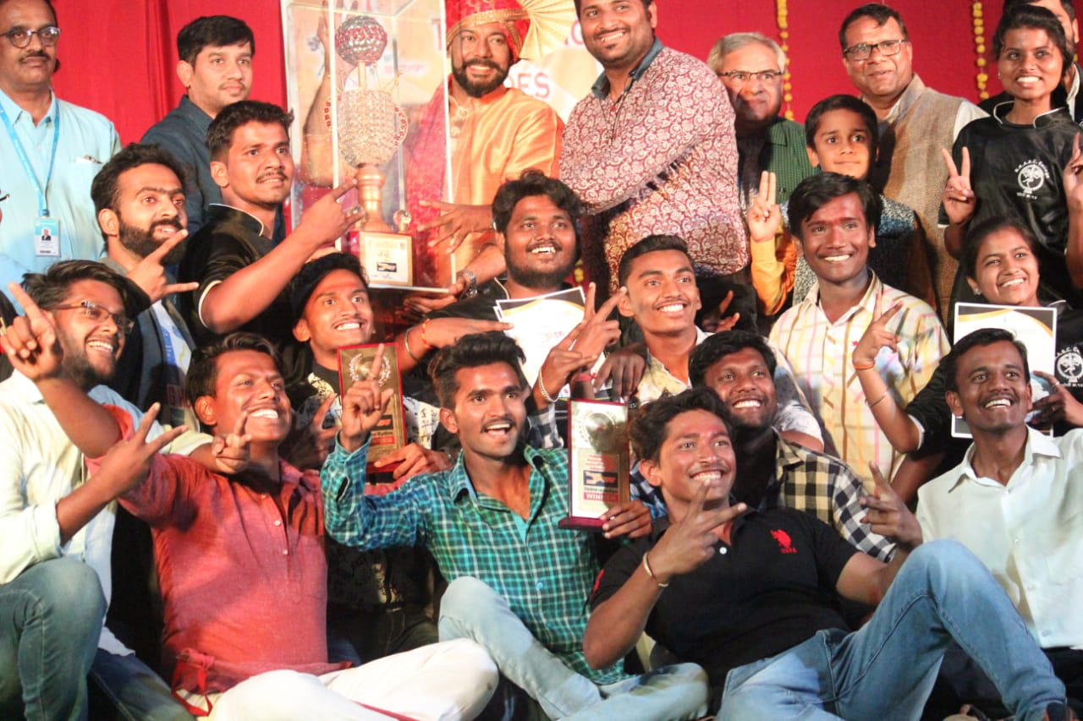

Winner Team of Vasant Karandak 1. Group Dance 1st, 2. Street Play 1st 3. Photography 1st, organized Vasant Dada Patil Technical Institute, Budhgav dt. 23 Feb. 2019

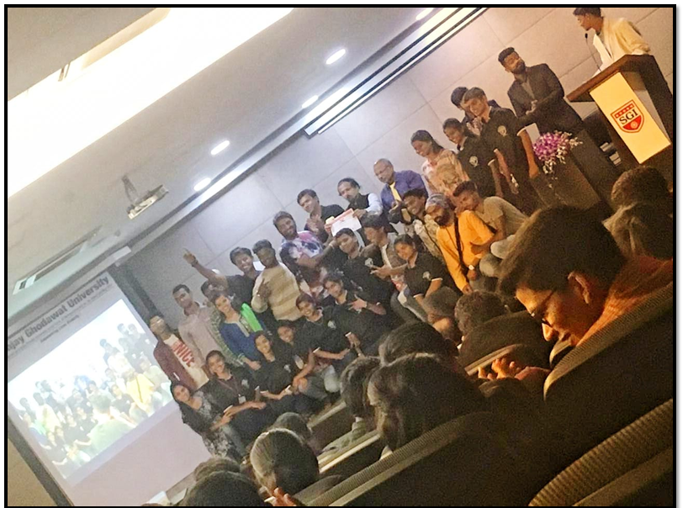

Vibrant Dance Championship Ghodawat Uni., Atigre, 1. Group Dance 1st, 2. Photography 1st, 25 & 27 Feb. 2019