CURRICULUM VITAE

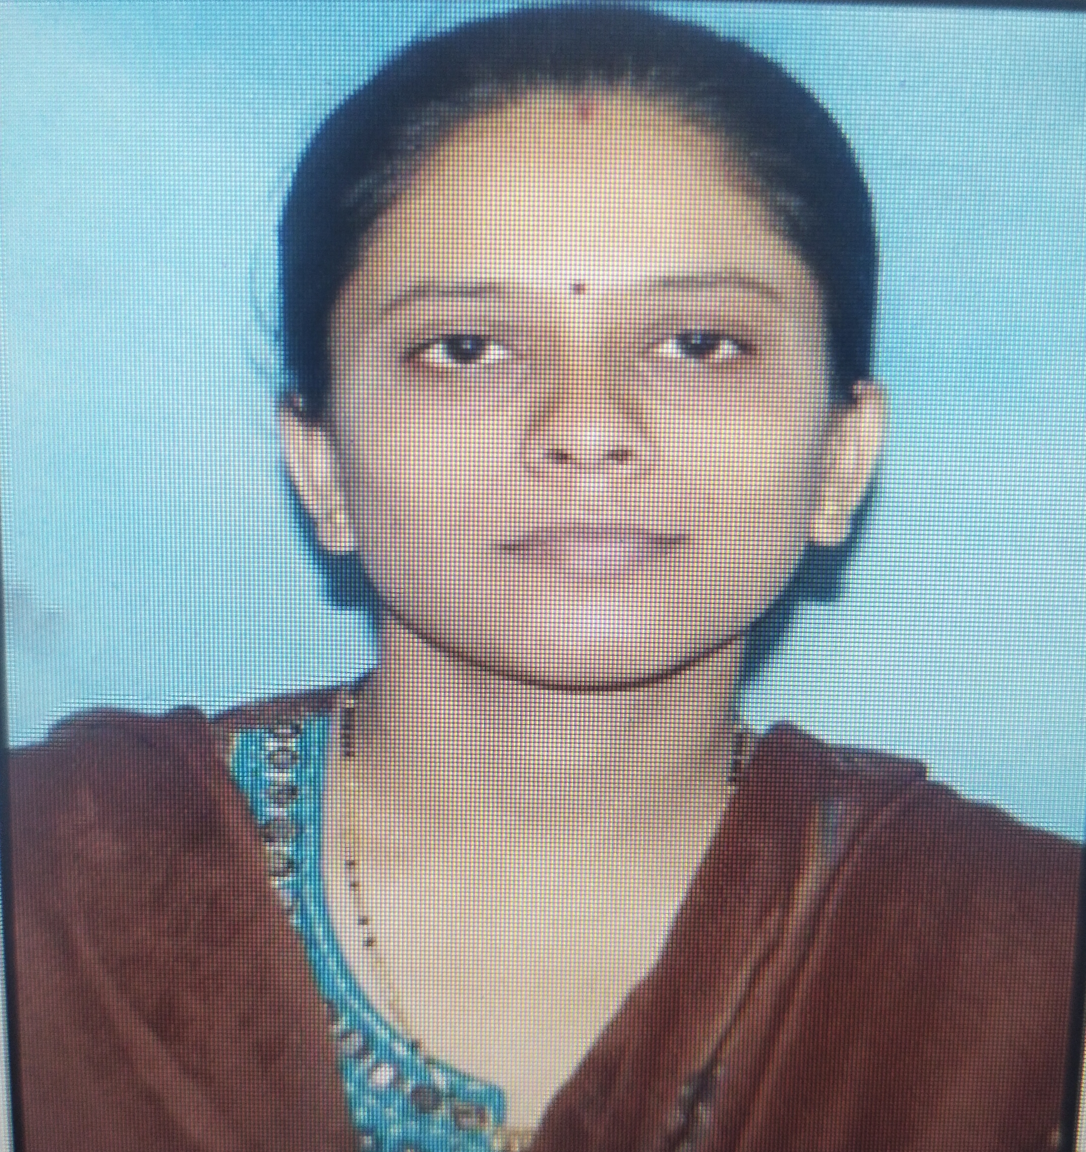

Paste

Recent

Photo

**PERSONAL DETAILS**

1. **Name : Dr. Varsha Ramesh Dawande**
2. **Permanent Address : c/o Sudip D. Hambar, 2416, Bajarpeth Kurundwad.**

**Tal. Shirol, dist. Kolhapur**

1. **Designation :Assistant Professor**
2. **Qualification : Ph.D in Botany, MH-SET**
3. **Mobile Number : 8308509249**
4. **e-mail :vrdawande@gmail.com**
5. **Vidwan Id :344551**
6. **Date of Birth : 21 July 1983**
7. **Gender : Female**

**Educational Qualification:**

|  |  |  |  |  |  |
| --- | --- | --- | --- | --- | --- |
| **Degree /Qualification** | **School/ College/Institute** | **Board/ University** | **Passing Year** | **Class & Percentage** | **Specialization** |
| Ph.D. | Shivaji University, Kolhapur | Shivaji University, Kolhapur | 2017 |  | Botany |
| M. Phil. |  |  |  |  |  |
| SET | MH-SET | MH-SET | 2017 |  | Life science |
| NET |  |  |  |  |  |
| M.Sc. | S.P.P.U, Pune | S.P.P.U, Pune | 2005 | 1st Class  65% | Cytogenetics |
| B.Sc. | S.P.P.U, Pune | S.P.P.U, Pune | 2003 | 1st Class with distinction  77% | Botany |
| HSC | Maharashtra State board | Maharashtra State board | 2000 | 1st Class  65% | Physics, Chemistry, Mathematics and Biology |
| SSC | Maharashtra State board | Maharashtra State board | 1998 | 1st Class  74% |  |
| Other |  |  |  |  |  |

1. **Ph.D. thesis title : “Studies in Genus Eulophia L. from Western Ghats.”**

**Guide’s Name :** **Dr. R.V. Gurav**

1. **Research Specializations : Botany**
2. **Awards /Achievements :**
3. **Date of recognition as PG teacher** (if applicable) **:**
4. **Date of recognition as Research Guide** (if applicable)**:**
5. **Number of students completed M.Phil. /Ph.D. degree under your supervision**
6. **Number of Research Students currently working under your supervision :**
7. **Teaching Experience:**

**UG level**:……2…years…….months

**PG level**:.……3…years… 7 .months

|  |  |  |  |  |  |  |
| --- | --- | --- | --- | --- | --- | --- |
| **Sr. No.** | **Designation / Post held** | **Name of the College / Institute** | **Nature of appointment** | **Period** | | **Experience in Years** |
| **From** | **to** |
| 1. | Asst. Prof. | Miraj Mahavidyalaya Miraj, | Full time non-grant | July 2018 | March 2019 | 1 |
| 2. | Asst. Prof. | D. K.A.S.C college , Ichalkaranji | Full time non-grant  ( P.G. dept. of Botany) | July 2019 till date |  | 3 |
| **Total** | | | | | | 4 |

1. **Experience in this College:3 year7 months**
2. **Research Articles Published :** 4

**Total citations: …….. (Google scholar) h-index: …….(Google scholar)**

**Link to the Google scholar account:**

|  |  |  |  |  |  |  |  |  |  |
| --- | --- | --- | --- | --- | --- | --- | --- | --- | --- |
| **Sr. No.** | **Title of paper** | **Name of the author/s** | **Department of the teacher** | **Name of journal** | **Year of publication** | **ISSN** | **Link to the recognition in UGC enlistment of the Journal /Digital Object Identifier (doi) number** | | |
| **Link to website of the Journal** | **Link to article / paper / abstract of the article** | **Is it listed in UGC Care list** |
|  | In-vitro seed germination and effect of growth  regulators on Subsequent development of protocorms of Eulophia nuda lindl., | Varsha Dawande and Rajaram Gurav, | Dept. of Botany, Shivaji University,  Kolhapur | International  Journal of Applied sciences and Biotechnology.Vol.3(2);243-247. | 2015 | ISSN 2091-2609 |  | <https://doi.org/10.3126/ijasbt.v3i2.12476> |  |
|  | Effect of cytokinins on shoot induction from  seed derived rhizomes in Eulophia nuda Lindl. | Varsha Dawande and Rajaram Gurav, | Dept. of Botany, Shivaji University,  Kolhapur | International journal of Current  Research, 7,(5),16383-16386. | 2015 | ISSN: 0975-833X | http://www.journalcra.com/ |  |  |
|  | Total phenolics, flavonoids content and  antioxidant activities of some Eulophia species. | Varsha Dawande and Rajaram Gurav, | Dept. of Botany, Shivaji University,  Kolhapur | Journal of Medicinal Plants Studies 2017; 5(2): 106-111 | 2017 | ISSN (E): 2320-3862 ISSN (P): 2394-0530 | www.plantsjournal.com |  |  |
|  | Qualitative analysis of phytochemical in Eulophia  nuda using LCMS. | Varsha Dawande and Rajaram Gurav, | Dept. of Botany, Shivaji University,  Kolhapur | Journal of Medicinal Plants Studies 2021; 9(3): 136-140 | 2021 | ISSN (E): 2320-3862 ISSN (P): 2394-0530 | www.plantsjournal.com |  |  |

1. **Number of books and chapters in edited volumes/books published and papers published in national/ international conference proceedings:**

|  |  |  |  |  |  |  |  |  |
| --- | --- | --- | --- | --- | --- | --- | --- | --- |
| **Sr. No.** | **Title of the book/chapters published/ Title of the paper** | **Title of the proceedings of the conference** | **Name of the conference** | **National / International** | **Year of publication** | **ISBN** | **Affiliating Institute at the time of publication** | **Name of the publisher** |
| **1.** |  |  |  |  |  |  |  |  |
| **2.** |  |  |  |  |  |  |  |  |

1. **Details of Workshop/ Seminar/ Conference/ Symposia Attended/ Participated/ Presented:**

**National: ….. 3 International: …..**

|  |  |  |  |  |
| --- | --- | --- | --- | --- |
| **Sr. No.** | **Name of conf., workshop, seminar, symposia** | **Date** | **Level** | **Role (Attended, presented, participated)** |
| 1 | National Symposium held on the occasion of 30 th meeting of the Plant Tissue Culture  Association of India organized by IHBT, Palampur, | 3rd -4th April 2009. | National | Paper presented in symposia  Varsha R Dawande and S.R.Thengane, ‘Regeneration of Abelmoschus esculentus L’ |
| 2 | National Symposium held on the occasion of 31 st meeting of the Plant Tissue Culture  Association of India organized by University of Kolkata | 3rd -5th March 2010. | National | Paper presented in symposia  Varsha R Dawande and S.R.Thengane, ‘De- novo shoot regeneration and production of  plants from leaf explants of Garcinia indica female plant’ |
| 3 | National seminar on recent advances in life sciences with special reference to biotechnology organized by Department of Life sciences, Smt. Kasturbai Walchand College,  Sangali (MS), | 3rd and 4th January 2013. | National | Paper presented in symposia  Varsha R Dawande and K. S.Patil, “In-vitro seed germination of *Uraria picta.”* |

1. **Lectures Delivered at Workshop/ Seminar/ Conference/ Symposia and other as Resource Person :**

|  |  |  |  |  |
| --- | --- | --- | --- | --- |
| **Sr. No.** | **Name of conf., workshop, seminar, symposia** | **Date** | **Level** | **Role (Attended, presented, participated)** |
|  |  |  |  |  |

1. **Projects ongoing/completed**

|  |  |  |  |  |  |  |  |
| --- | --- | --- | --- | --- | --- | --- | --- |
| **Sr. No.** | **Name of the research project/ endowment** | **Name of the Principal Investigator/Co-investigator** | **Department of Principal Investigator** | **Year of Award** | **Amount Sanctioned** | **Duration of the project** | **Name of the Funding Agency** |
| **1.** |  |  |  |  |  |  |  |
| **2.** |  |  |  |  |  |  |  |

1. **Details of teachers undergoing Faculty Development Programmes, Professional Development Programmes, Orientation / Induction Programmes, Refresher Course, Short Term Course / Certificate Course (MSCIT, TALLEY, JAVA, MOOCS) etc.)**

|  |  |  |
| --- | --- | --- |
| **Sr. No.** | **Title of the program** | **Duration (from – to)**  **(DD-MM-YYYY)** |
| 1 |  |  |
| 2 |  |  |
| 3 |  |  |

1. **Membership of Institutional /Professional bodies:**
2. **DECLARATION:**

I hereby declare that all information in this document is true, complete and correct to the best of my knowledge and belief.

**Place: Ichalkaranji Signature**

**Date: (Name- )**