CURRICULUM VITAE

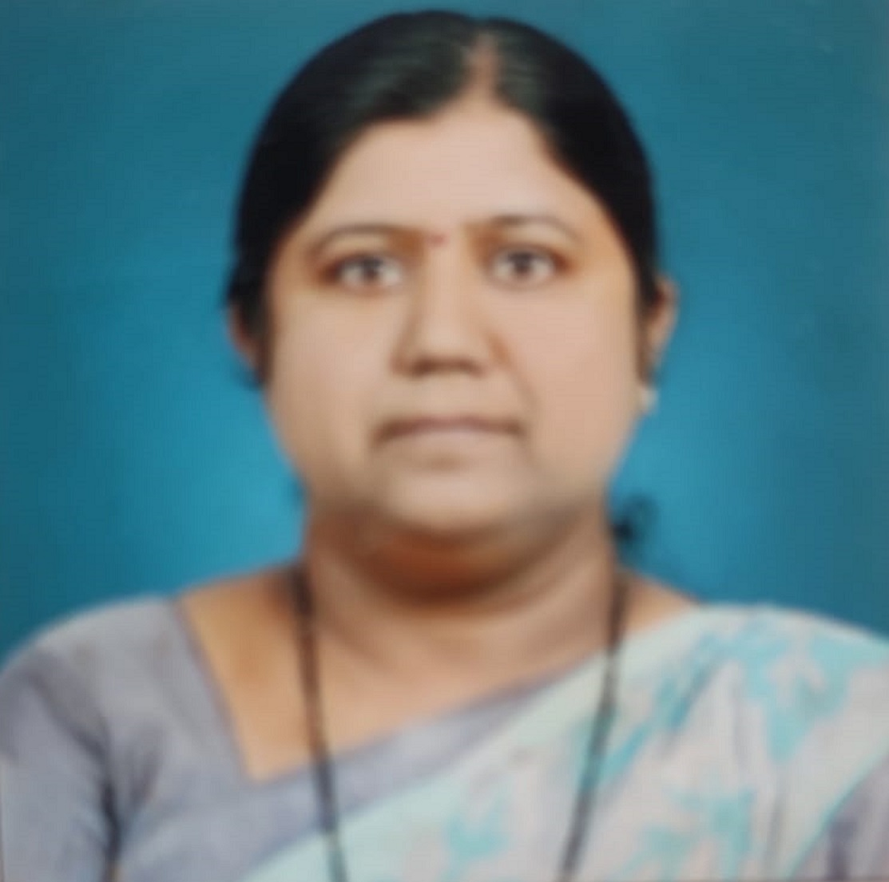

Paste

Recent

Photo

**PERSONAL DETAILS**

1. **Name : Mrs. BharatiShekharDopare**
2. **Permanent Address : Home No. 1619, Ward No. 24, Bhoi Nagar,**

**Shahapur, Ichalkaranji.**

1. **Designation : Assistant Professor (CHB)**
2. **Qualification : M.Sc., B.Ed., (Ph.D. Sumbited)**
3. **Mobile Number : 9765258466**
4. **e-mail : bsdopare@gmail.com**
5. **Vidwan Id : 358568**
6. **Date of Birth : 15/08/1973**
7. **Gender : Female**

**Educational Qualification:**

|  |  |  |  |  |  |
| --- | --- | --- | --- | --- | --- |
| **Degree /Qualification** | **School/ College/Institute** | **Board/ University** | **Passing Year** | **Class & Percentage** | **Specialization** |
| Ph.D. | D.K.A.S.C. College, Ichalkaranji. | Shivaji University | Submited |  | Mycology |
| M. Phil. |  |  |  |  |  |
| SET |  |  |  |  |  |
| NET |  |  |  |  |  |
| M.Sc. . | Shivaji University | Shivaji University | 2000 | IIndClass  58.89% | Mycology |
| B.Sc. | AjaraMahavidyalaya | Shivaji University | 1998 | Ist Class  66.06% | Botany |
| HSC | JagrutiMahavidyalaya | Pune Board | 1995 | IIndClass  56% |  |
| SSC | TavnappaPataneHighschool, Kolhapur. | Pune Board | 1993 | Ist Class  62% |  |
| MS CIT | Vikas Computer, Murgud. |  | 2003 | 73% |  |

1. **Ph.D. thesis title : TAXONOMICAL STUDIES IN BLACK**

**MILDEW MICROFUNGI OF KOLHAPUR DISTRICT**

**Guide’s Name : PRO. (DR.) C. R. PATIL**

1. **ResearchSpecializations : Mycology**
2. **Awards /Achievements : ____**
3. **Date of recognition as PG teacher** (if applicable) **: _____**
4. **Date of recognition as Research Guide** (if applicable)**: _____**
5. **Number of students completed M.Phil. /Ph.D. degree under your supervision**
6. **Number of Research Students currently working under your supervision :**
7. **Teaching Experience:**

**UG level**: 13 years ---- months

**PG level:**  .…… years…….months

|  |  |  |  |  |  |  |
| --- | --- | --- | --- | --- | --- | --- |
| **Sr. No.** | **Designation / Post held** | **Name of the College / Institute** | **Nature of appointment** | **Period** | | **Experience in Years** |
| **From** | **to** |
| 1. | Assistant Professor | D.K.A.S.C. College, Ichalkaranji. | CHB | 15 JUNE 2010 | Till Date | 13 |
| **Total** | | | | | | 13 |

1. **Experience in this College: 13 years…7.months**
2. **Research Articles Published :**(Write number here)

**Total citations: …….. (Google scholar) h-index: …….(Google scholar)**

**Link to the Google scholar account: https://scholar.google.com/citations?view_op=new_articles&hl=hi&imq=Bharati+Shekhar+Dopare#**

|  |  |  |  |  |  |  |  |  |  |
| --- | --- | --- | --- | --- | --- | --- | --- | --- | --- |
| **Sr. No.** | **Title of paper** | **Name of the author/s** | **Department of the teacher** | **Name of journal** | **Year of publication** | **ISSN** | **Link to the recognition in UGC enlistment of the Journal /Digital Object Identifier (doi) number** | | |
| **Link to website of the Journal** | **Link to article / paper / abstract of the article** | **Is it listed in UGC Care list** |
|  |  |  |  |  |  |  |  |  |  |

1. **Number of books and chapters in edited volumes/books published and papers published in national/ international conference proceedings:**

|  |  |  |  |  |  |  |  |  |
| --- | --- | --- | --- | --- | --- | --- | --- | --- |
| **Sr. No.** | **Title of the book/chapters published/ Title of the paper** | **Title of the proceedings of the conference** | **Name of the conference** | **National / International** | **Year of publication** | **ISBN** | **Affiliating Institute at the time of publication** | **Name of the publisher** |
| **1.** | Lecideopsella arnaudii (C. and M. Moreau) Dopare and Patil Comb. Nava.  A Black Mildew from Western Ghats - I | International Conference on Advances in Pure and Applied Sciences | ICAPAS – 2019 | International | 2019 | E – issn 2348 -1269 | Dattajirao Kadam Arts, Science and Commerce College, IChalakaranji | International journal of research and analytical reviews. |
| **2.** | Meliola parlensis Sp. Nova As a New Species of Black Mildew from Western Ghats – II | One Day Online International Multidisciplinary Conference on Online Resources in Library Science, Social Science and Pure Science | - | International | 2021 | ISSN NO. 0976 – 0822 | Dattajirao Kadam Arts, Science and Commerce College, IChalakaranji | Kalyan bharati |
| **3.** | Some New Species of Black Mildews from Western Ghats -III | Multidisciplinary Approch in Basic and Applied Science | MABAS-2023 | International |  |  | Dattajirao Kadam Arts, Science and Commerce College, IChalakaranji | Communicated |

1. **Details of Workshop/ Seminar/ Conference/ Symposia Attended/ Participated/ Presented:**

**National: ….. International: …..**

|  |  |  |  |  |
| --- | --- | --- | --- | --- |
| **Sr. No.** | **Name of conf., workshop, seminar, symposia** | **Date** | **Level** | **Role (Attended, presented, participated)** |
| **1.** | International Ozone -Day Exhibition | 16th Sept 2010 | State | **Attended** |
| **2.** | Role of IQAC in Quality Enhancement of Higher Education | 3rd December 2011 | National | **Attended** |
| **3.** | Biodiversity Conservation for Livelihood | 14th and 15th December, 2012 | International | **Attended** |
| **4.** | DUTIES, RIGHTS AND RESPONSIBILITIES OF THE SENIOR COLLEGE TEACHERS | 23rd January, 2012 | National | **Attended** |
| **5.** | **पेन्शन पेपर तयार करणे आणि कागदरहीत पत्रव्यवहार करणे** | **३० मार्च २०१३** | National | **Attended** |
| **6.** | International Ozone Day | 16th September 2015 | State | **Attended** |
| **7.** | Revised Syllabus of Botany for B.Sc. - III Paper XIII to XVI | 23rd September 2015 | State | **Attended** |
| **8.** | Gift Articles from Plant Resources | 14th January, 2015 | State | **Attended** |
| **9.** | Gift Articles From Plant Resources and Best from Waste | 2017-18 | State | **Attended** |
| **10.** | IQAR and Academic  Administration Audit in Revised Assessment and Accreditation Framework | 2018 | State | **Attended** |
| **11.** | Orientation for MH - CET and NEET | 29th December 2018 | State | **Attended** |
|  | Intellectual Property Rights | 25th Oct. 2018 | National | **Attended** |
| **12.** | Understanding Climate Change and Sustainable Development Goals for Safer Planet and a Sustainable Future | 10th January,2019 | National |  |
| **13.** | BONSAI - AN ART OF LIVING | 8th January 2022 | State |  |
| **14.** | Revised Syllabus of B.Sc.III, Botany (CBCS) Paper XI and XII | 9th Feb. 2021 | State | **Attended** |
| **15.** | Bonsai-An Art of Living | 8th Jan. 2022 | State | **Attended** |
| **16.** | National Education Policy-2022  Challenges Before Colleges and Teachers | 25th Aug. 2022 | National | **Attended** |

1. **Lectures Delivered at Workshop/ Seminar/ Conference/ Symposia and other as Resource Person :**

|  |  |  |  |  |
| --- | --- | --- | --- | --- |
| **Sr. No.** | **Name of conf., workshop, seminar, symposia** | **Date** | **Level** | **Role (Attended, presented, participated)** |
| **1.** | Under DBT scheme Guest Lecture on Research Methodology at LBS College Satara. | 21th March 2022 | State | **Presented** |

1. **Projects ongoing/completed**

|  |  |  |  |  |  |  |  |
| --- | --- | --- | --- | --- | --- | --- | --- |
| **Sr. No.** | **Name of the research project/ endowment** | **Name of the Principal Investigator/Co-investigator** | **Department of Principal Investigator** | **Year of Award** | **Amount Sanctioned** | **Duration of the project** | **Name of the Funding Agency** |

1. **Details of teachers undergoing Faculty Development Programmes, Professional Development Programmes, Orientation / Induction Programmes, Refresher Course, Short Term Course / Certificate Course (MSCIT, TALLEY, JAVA, MOOCS) etc.)**

|  |  |  |
| --- | --- | --- |
| **Sr. No.** | **Title of the program** | **Duration (from – to)**  **(DD-MM-YYYY)** |
|  | Nil |  |

1. **Membership of Institutional /Professional bodies: Nil**
2. **DECLARATION:**

I hereby declare that all information in this document is true, complete and correct to the best of my knowledge and belief.

**Place:Ichalkaranji Signature**

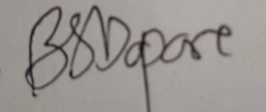

**Date:11/04/2023. (Name- BharatiShekharDopare)**