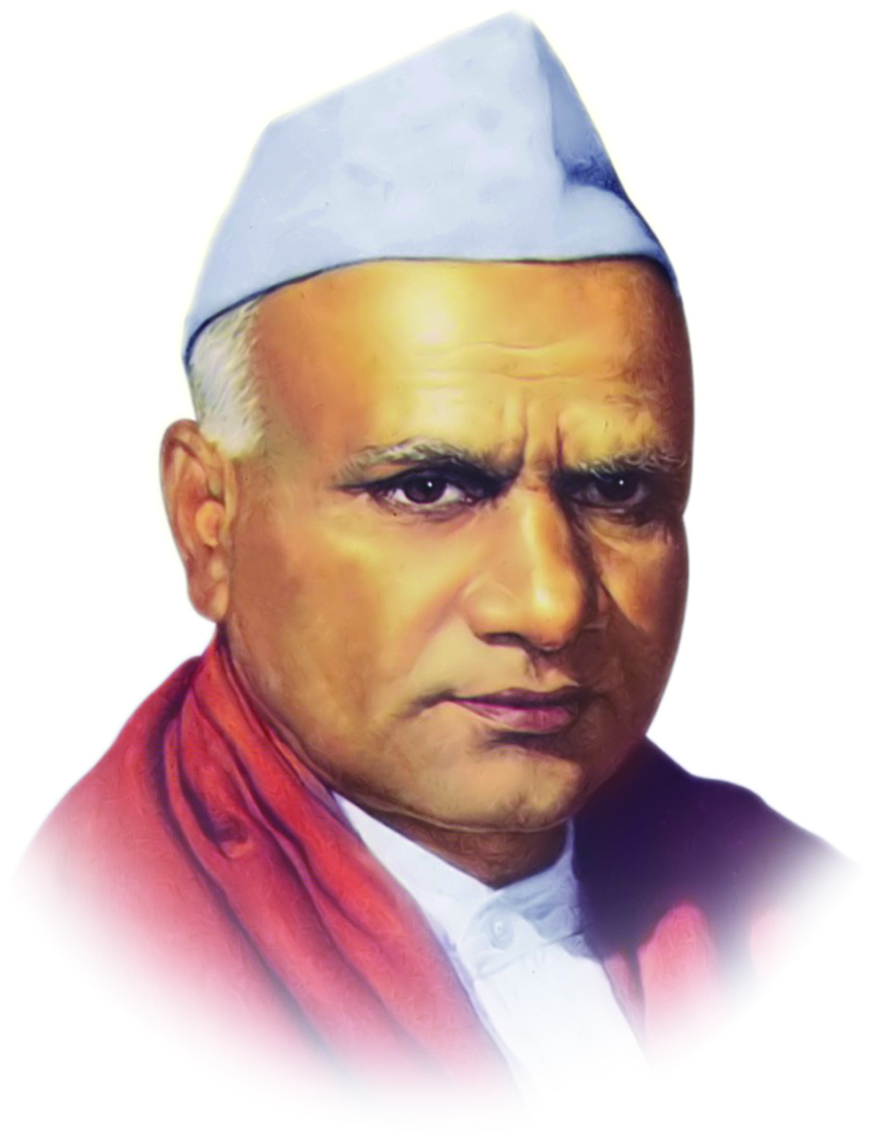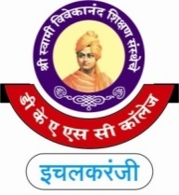

**“Dissemination of Education for Knowledge, Science and Culture”**

**-Shikshanmaharshi Dr. Bapuji Salunkhe**

**Shri Swami Vivekanand Shikshan Sanstha's**

**Dattajirao Kadam Arts, Science & Commerce College,**

**Ichalkaranji**

**DEPARTMENT OF COMMERCE (2024-25)**

**(B.Com & B.Com IT) Date- 21/01/2025**

**Visit to Ichalkaranji Garment Cluster Ltd.**

**Introduction by Shri. V.P. Patil Guidance by Mr. Prashant Chavan**

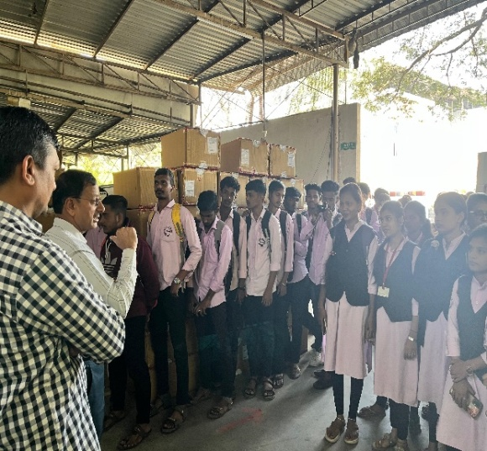 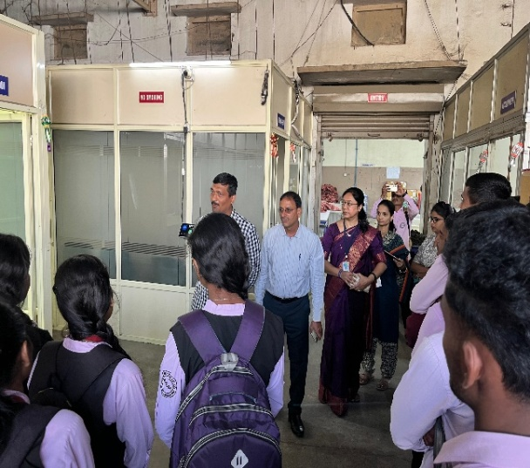

**Guidanceby Amruta Badawe Student - Teacher Exiting Photo**

