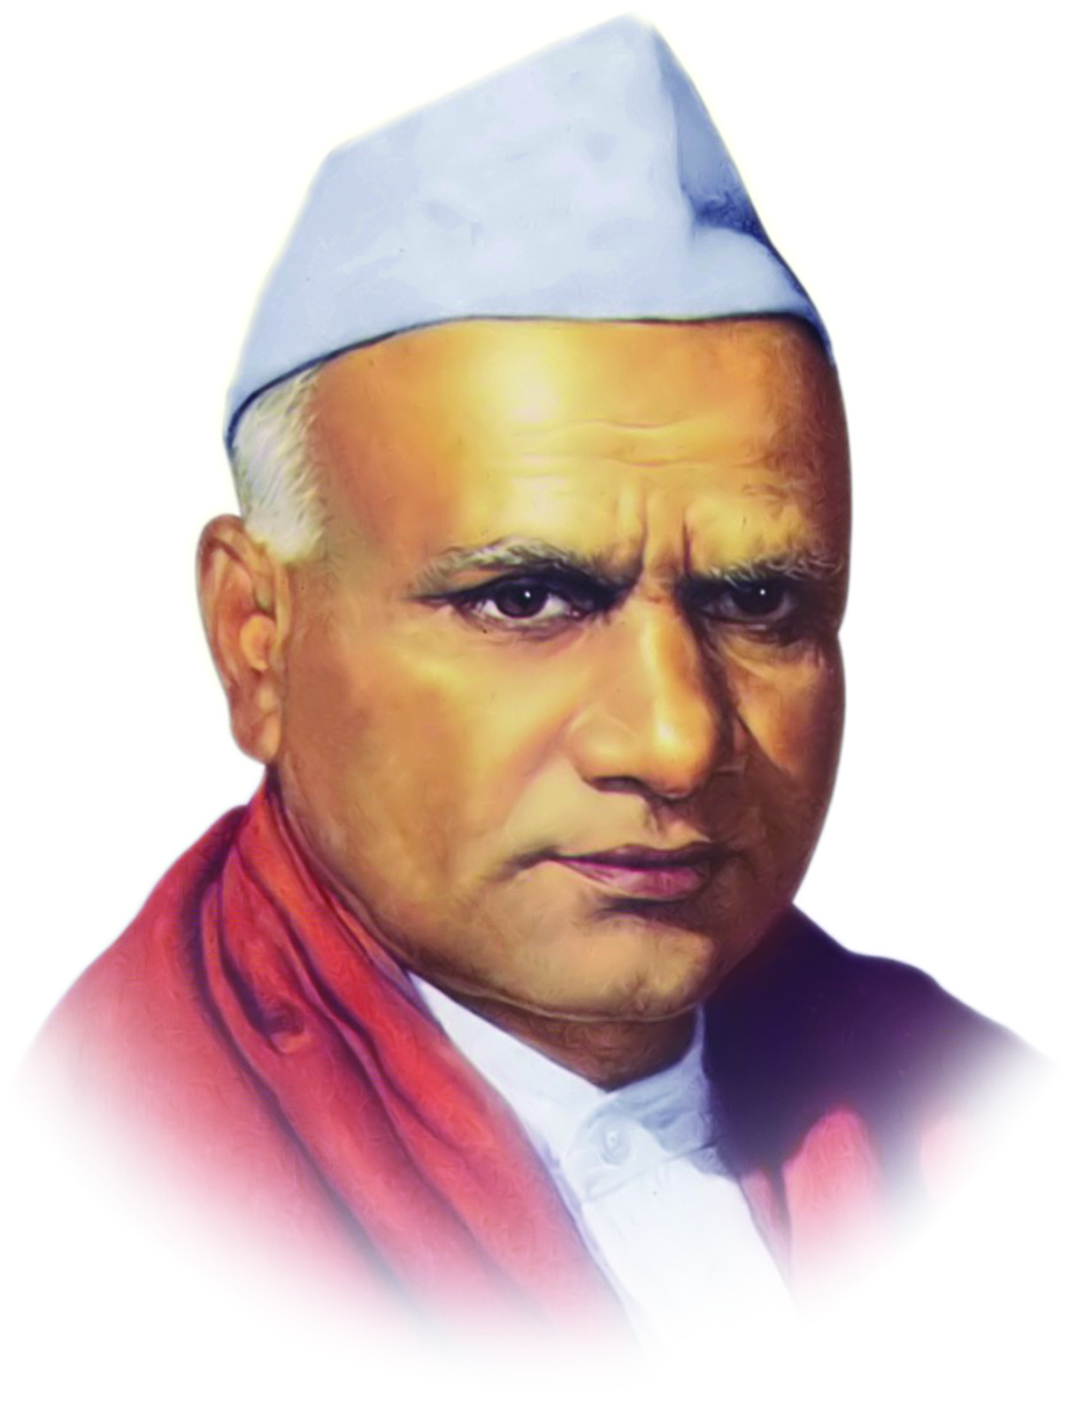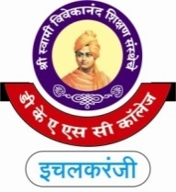

**“Dissemination of Education for Knowledge, Science and Culture”**

**-Shikshanmaharshi Dr. Bapuji Salunkhe**

**Shri Swami Vivekanand Shikshan Sanstha's**

**Dattajirao Kadam Arts, Science & Commerce College,**

**Ichalkaranji**

**DEPARTMENT OF COMMERCE (2024-25)**

**(B.Com & B.Com IT) Date- 02/01/2025**

**Mentor –Mentee Meeting**

**Introduction by Mrs. P.C. Parishwad Guidance by Principal Dr.S. M. Maner Sir**

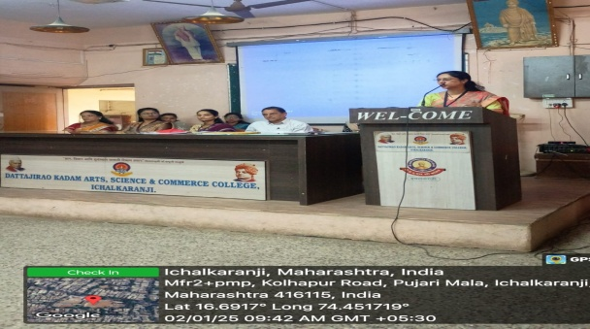 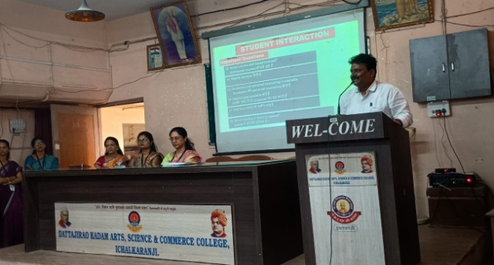

**Guidance by H.O.D. Shri V.P. Patil Sir Attentive Participation by Mentee**

