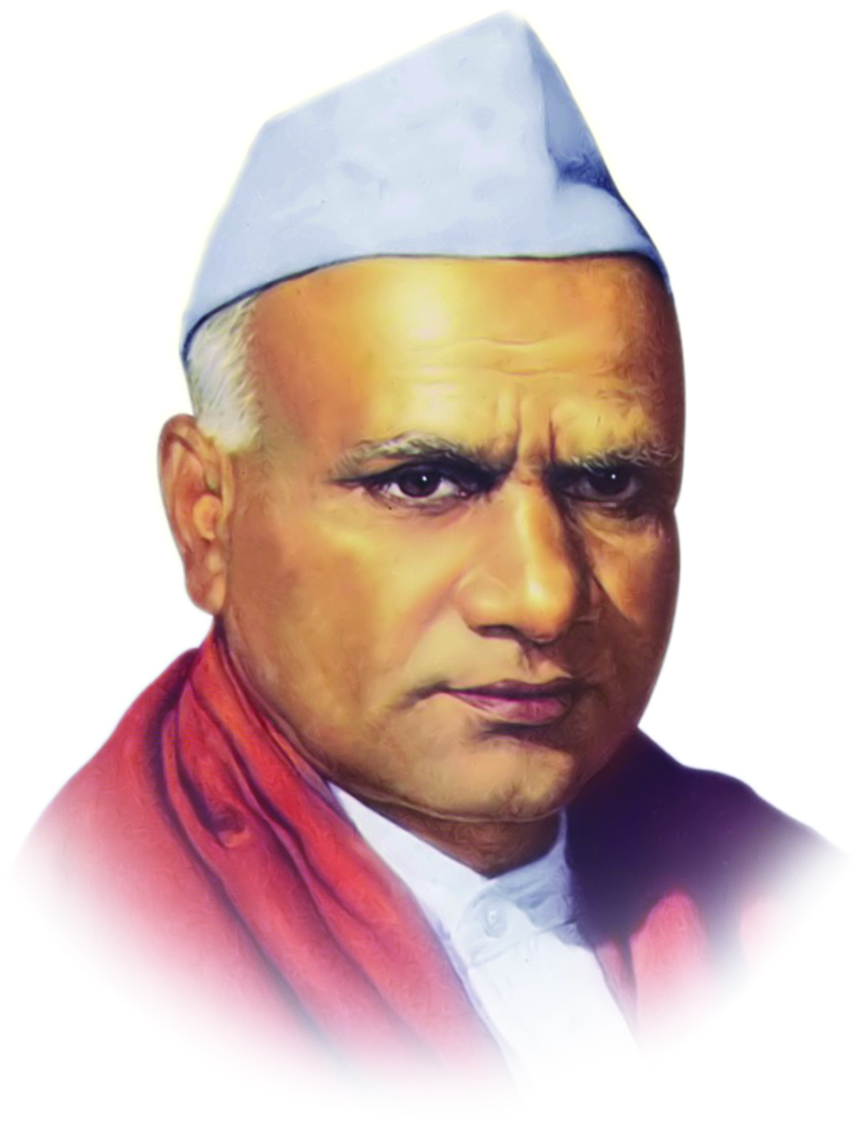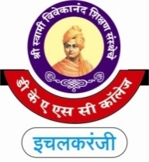

**“Dissemination of Education for Knowledge, Science and Culture”**

**-Shikshanmaharshi Dr. Bapuji Salunkhe**

**Shri Swami Vivekanand Shikshan Sanstha's**

**Dattajirao Kadam Arts, Science & Commerce College,**

**Ichalkaranji**

**DEPARTMENT OF B.Com IT (2024-25)**

**Date-22/01/2025**

**Wallpaper Presentation on Artificial Intelligence**

**Inugration by Principal Dr. S. M. Maner Presentation by Student**

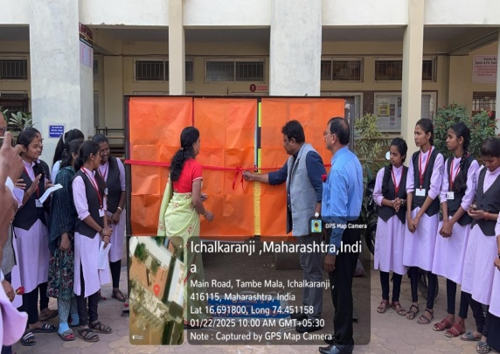 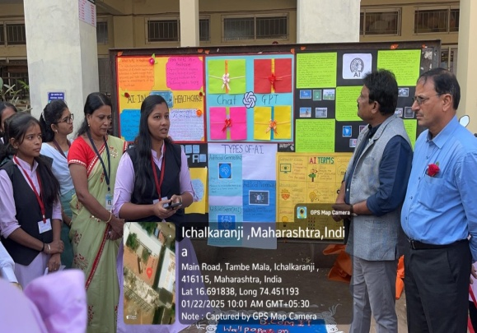

**Participated Students with Principal Other Faculty visit to the Presentation**

