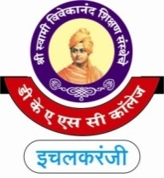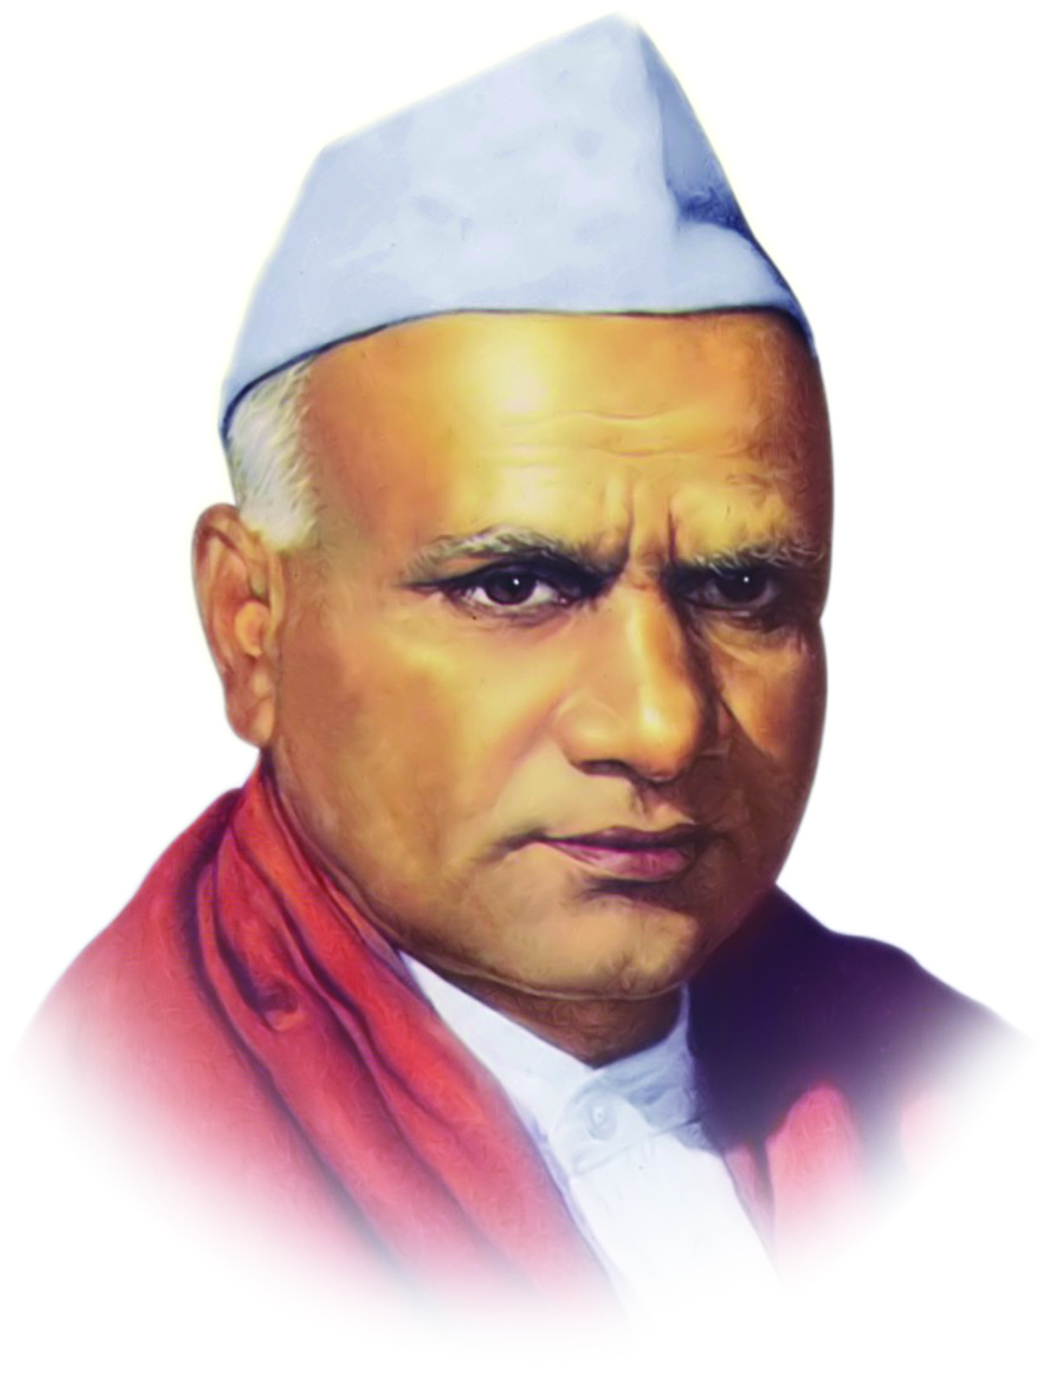

**“Dissemination of Education for Knowledge, Science and Culture”**

**-Shikshanmaharshi Dr. Bapuji Salunkhe**

**Shri Swami Vivekanand Shikshan Sanstha's**

**Dattajirao Kadam Arts, Science & Commerce College,**

**Ichalkaranji**

**DEPARTMENT OF COMMERCE (2024-25)**

**(B.Com & B.Com IT) Date-29/01/2025**

**Wallpaper on Digital Marketing**

**Inugration by Principal Dr. S.M. Maner sir** **Introduction By HOD Shri. V.P. Patil**

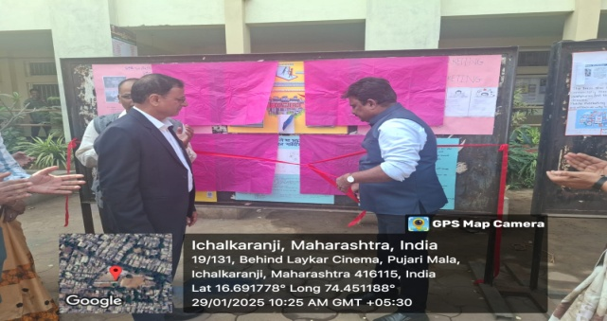 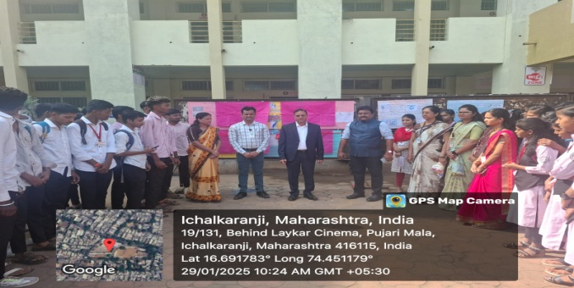

**Presentation by Student Participated Students with Teachers**

