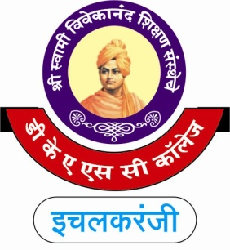**“Dissemination of Education for knowledge, Science and Culture”**

**-Shikshanmaharshi Dr. Bapuji Salunkhe**

**Shri Swami Vivekanand Shikshan Sanstha's**

**Dattajirao Kadam Arts, Science & Commerce College, Ich.**

**Department of Commerce (2018-19)**

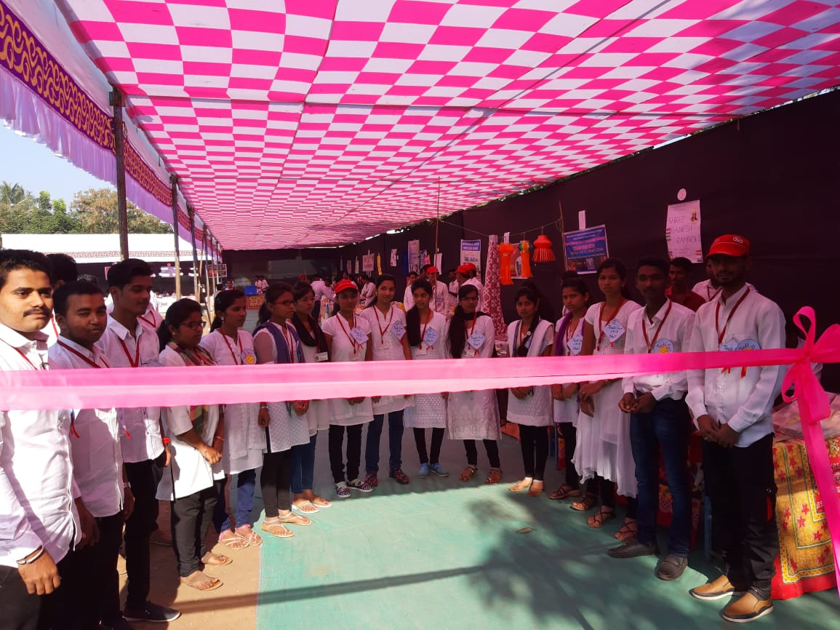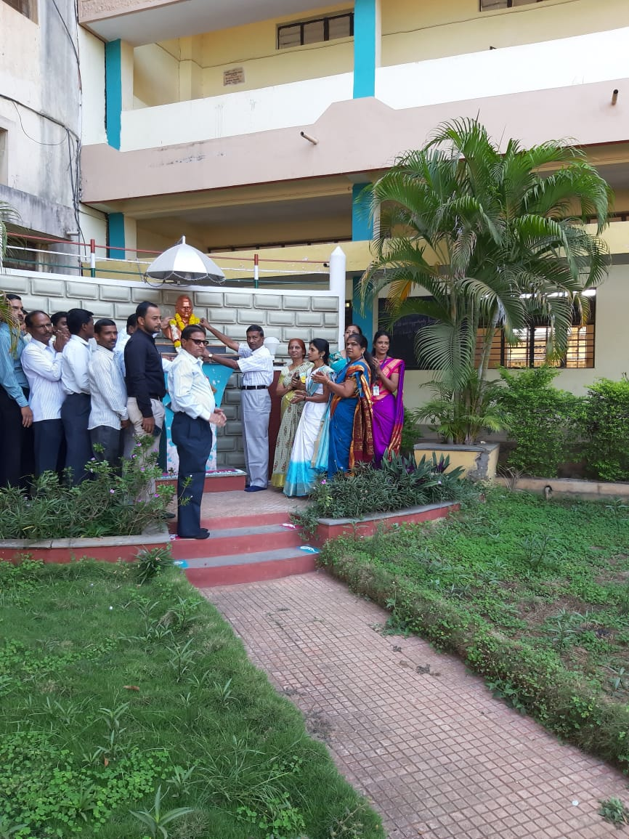**Trade Fair 2k18**

